**Building a Live SOC + Honeynet in Azure**

*Step-by-step lab documentation  
Date: August 09, 2025*

## Prerequisites

* Sign up for a free Azure account. You will need to provide a credit card, but you won't be charged unless you exceed the free usage limits or switch to a pay-as-you-go plan.
* Basic knowledge: Azure Resource Manager, VMs, NSGs, RDP/SSH, Microsoft Sentinel, Log Analytics, KQL.
* Tools used in lab: Azure Portal, Remote Desktop, SSH client, SQL Server (evaluation), SQL Server Management Studio (SSMS).

## Environment Setup

### 1. Create Resource Group

* Create a new Resource Group in Azure Portal in the chosen region (e.g., Asia Pacific, Southeast Asia). Think of a Resource Group as a folder for your cloud resources.
* Azure Portal > Resource Groups > Create (you can also create when you create virtual machines)

### 2. Deploy Virtual Machines

Windows VM:

* Name: Windows-VM
* Size: Minimum 2 vCPUs
* Authentication: Username: labuser, Password: your_password
* Place in (your-resource-group) and assign to lab-vnet

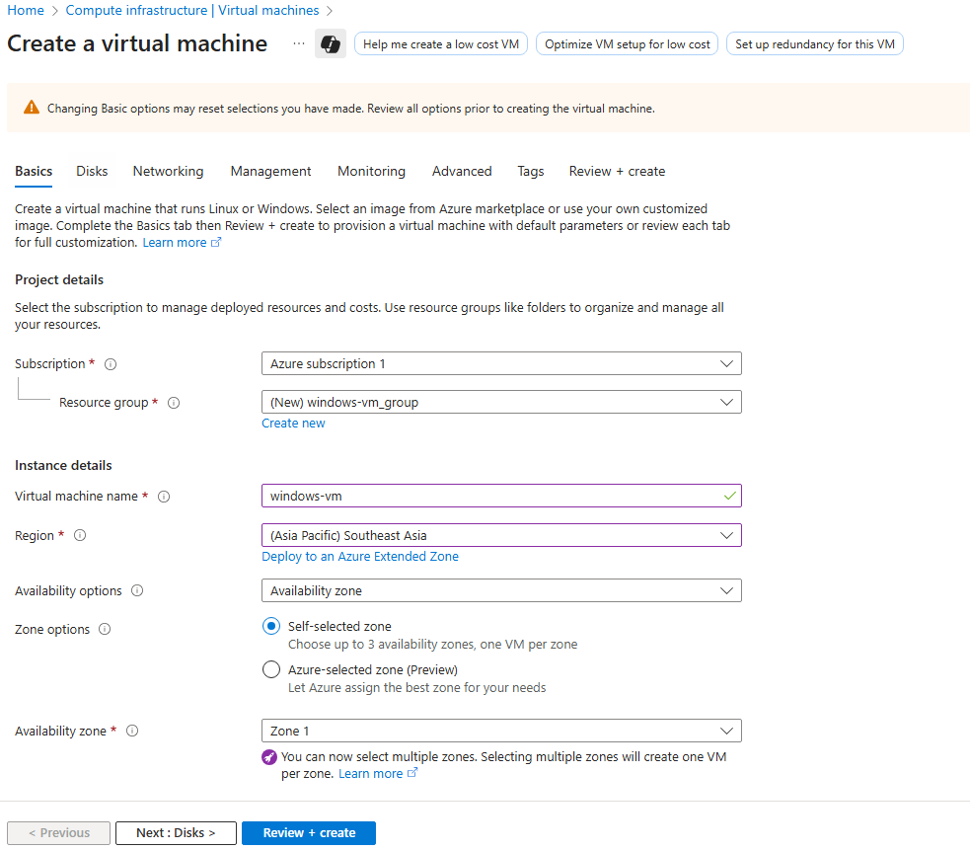

Windows vm specifications

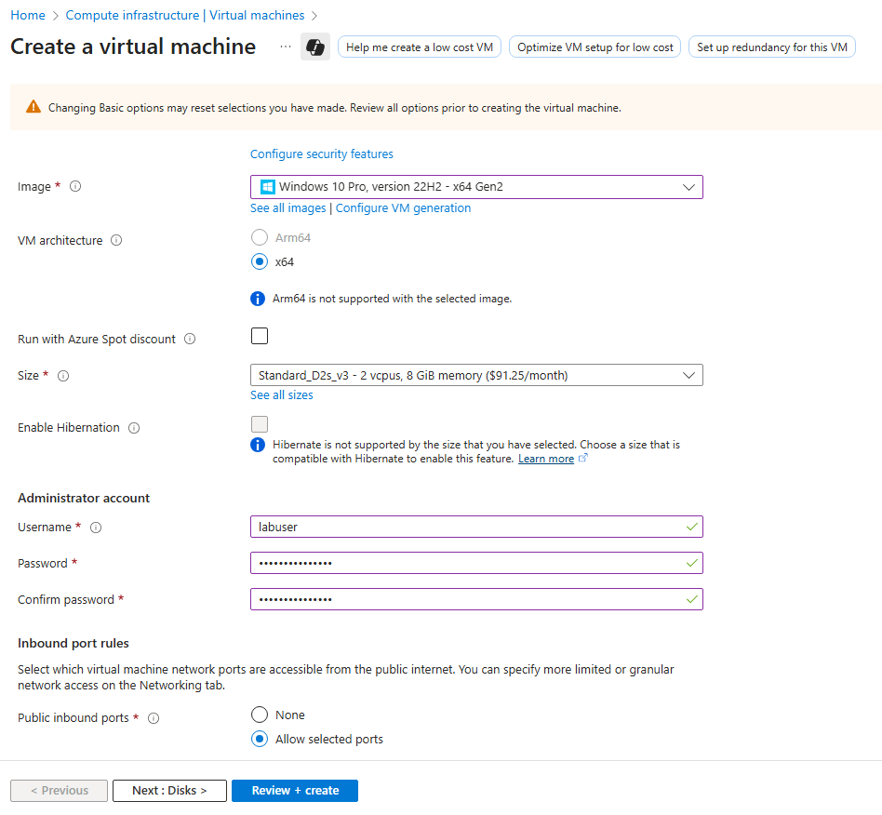

Add administrator username and password

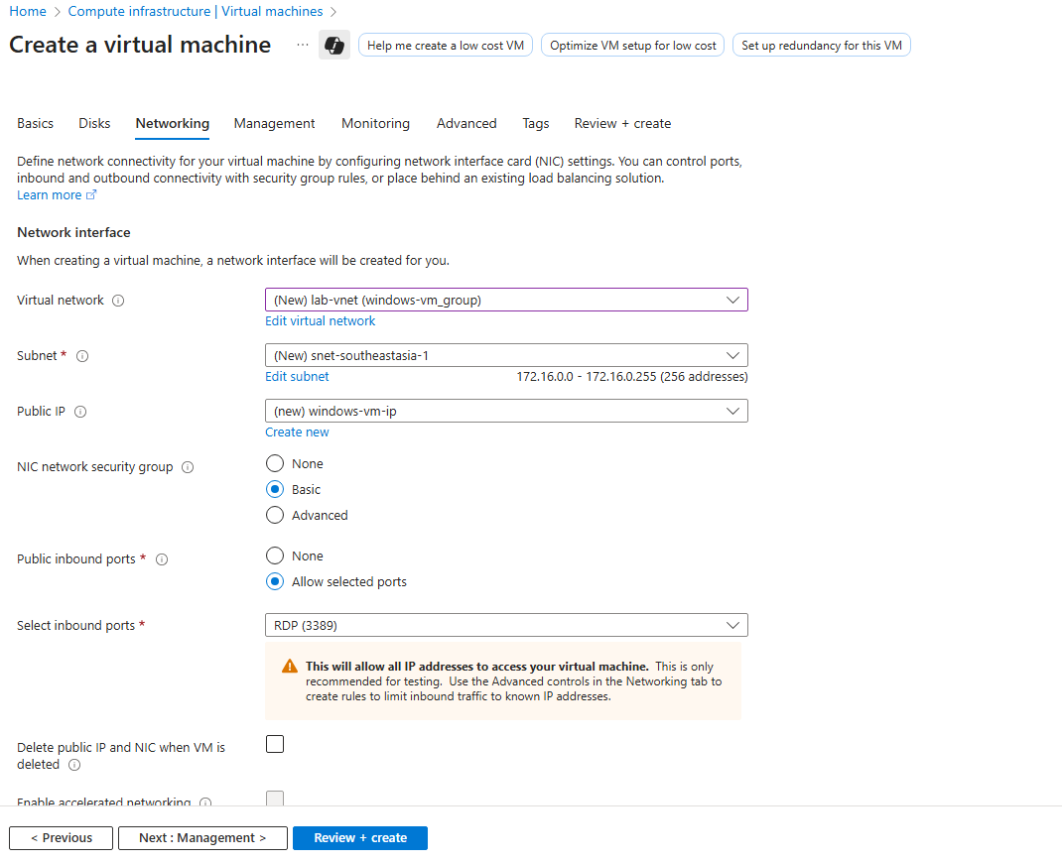

Configure virtual network to lab-vnet and subnet in region you live

**Linux VM:**

• Name: linux-vm

• Use same credentials and virtual network same as previous resource group.

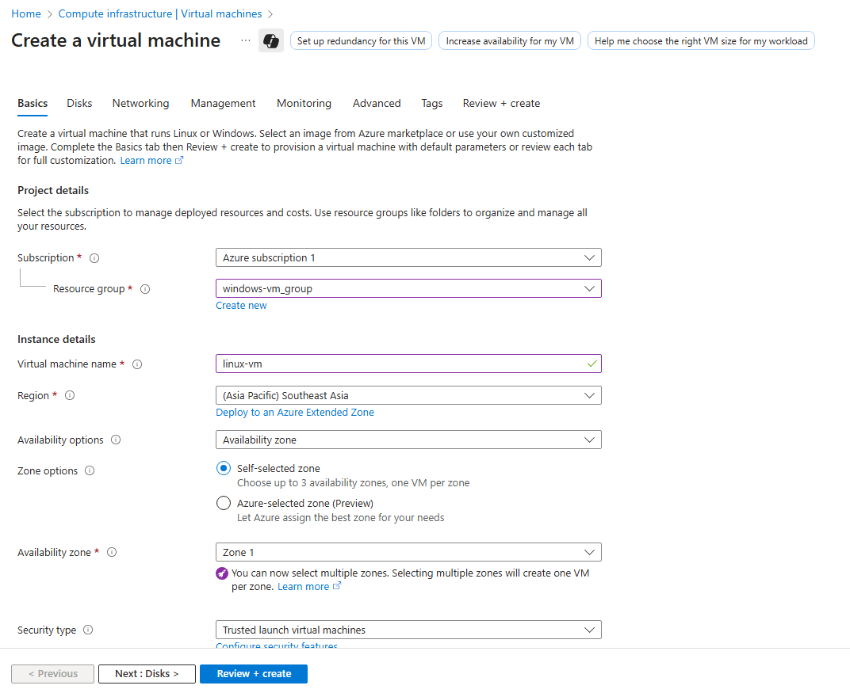

Linux vm specifications

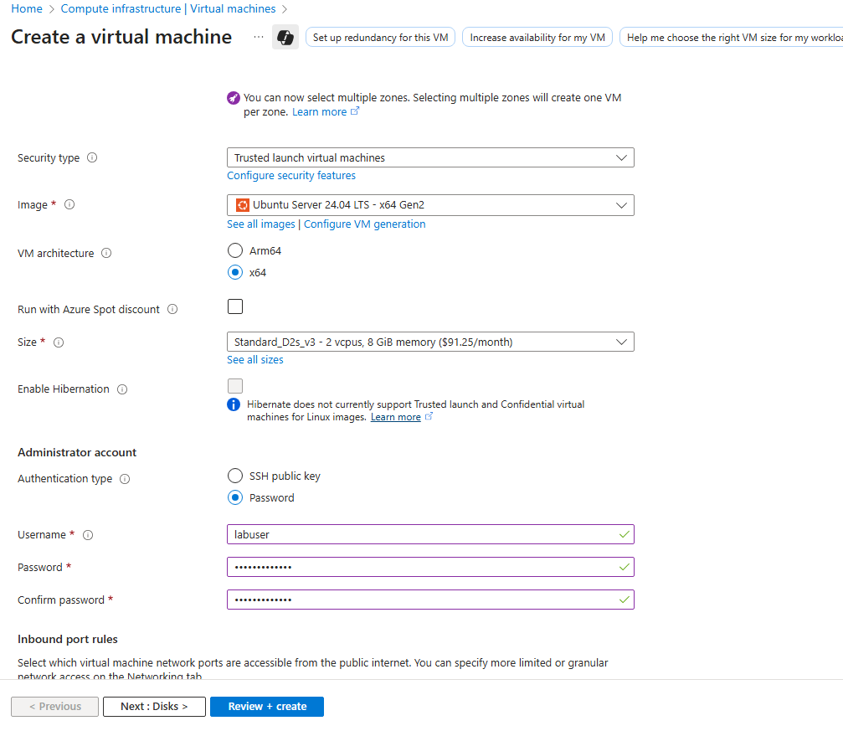

Add administrator username and password

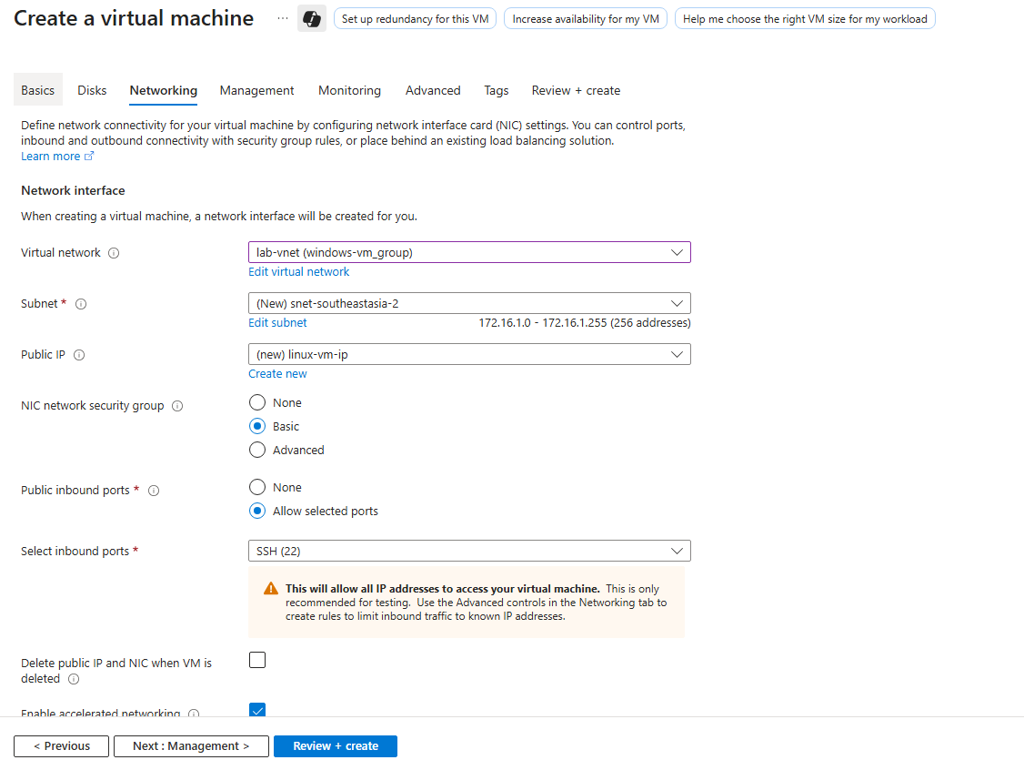

Configure virtual network to lab-vnet and subnet in region you live

### Configure NSGs to be Vulnerable (Simulation Only)

• Modify the Network Security Groups (NSGs) for both VMs by removing restrictive inbound rules and adding a permissive rule allowing Any source/Any destination / Any port / Any protocol (Allow).

**Warning**: This is intentionally insecure, use only in lab environments.

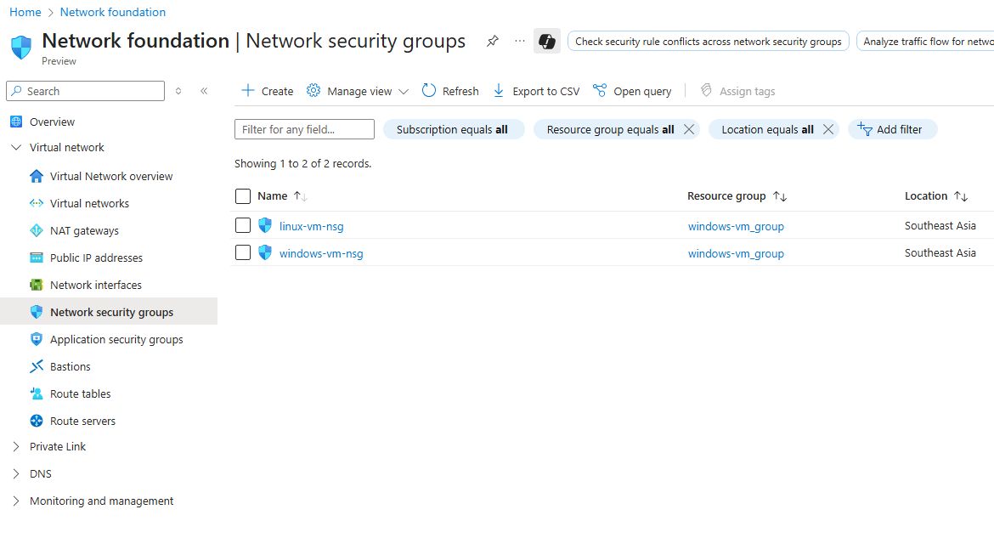

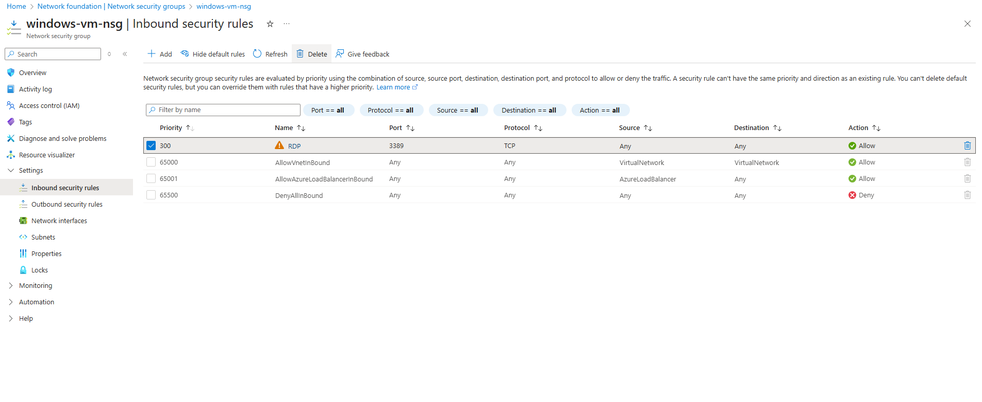

Delete default NSG’s settings for windows and new dangerous rule

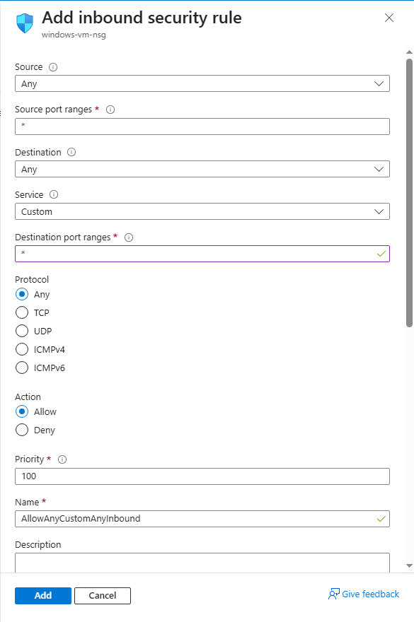

Windows inbound dangerous security rule

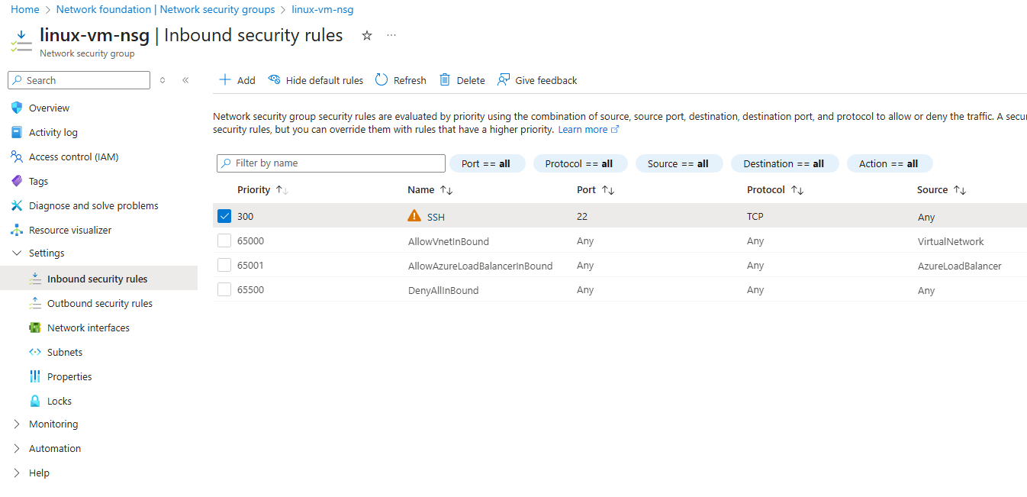

Delete default NSG’s settings for Linux

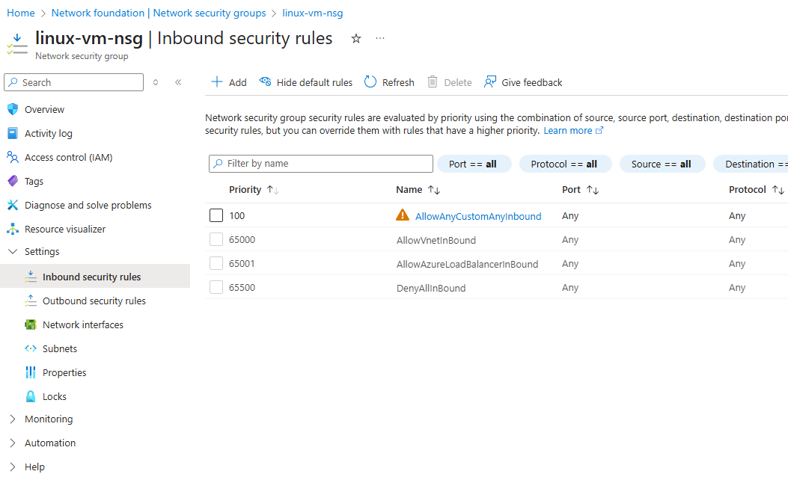

Linux inbound security dangerous rule same as windows nsg

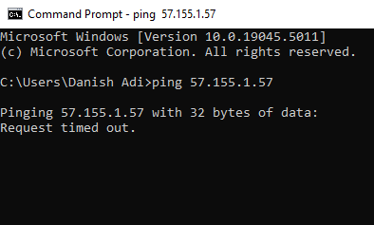

Ping test for windows vm

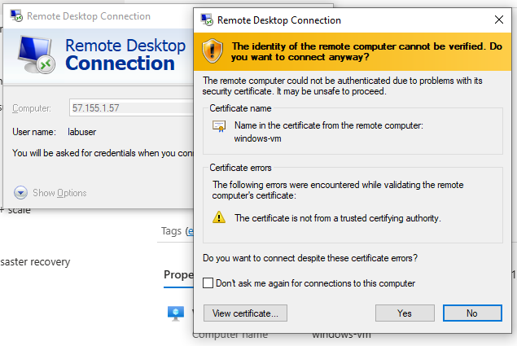

Login in to windows vm to turn off firewall

* Find your windows vm public address in virtual machines page in azure portal.

## Phase 2 — Simulate Realistic Attack Environment

### Disable Windows Firewall on Windows VM

• RDP into Windows-VM, open 'Windows Defender Firewall with Advanced Security' and disable Domain, Private, and Public profiles.

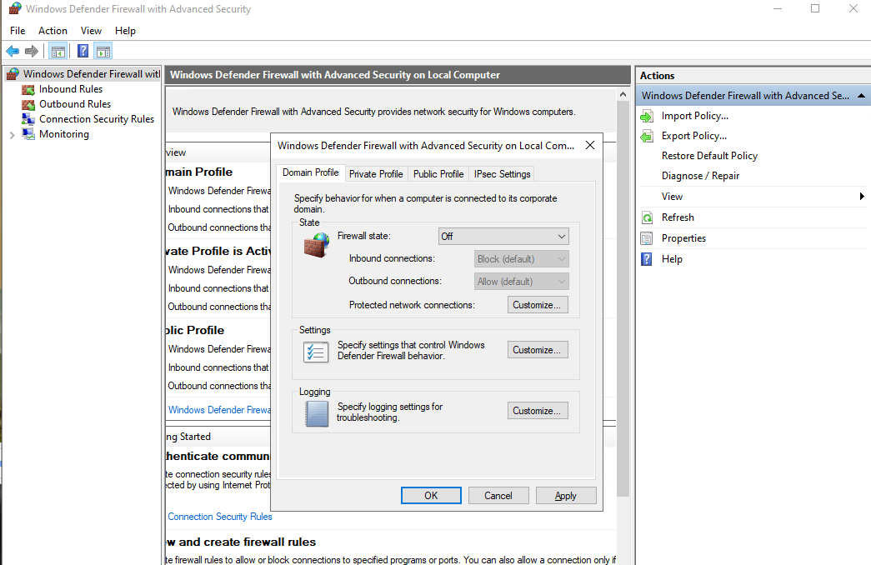

windows-vm firewall

### Install SQL Server on Windows VM

• Download SQL Server Evaluation ISO on the Windows VM.

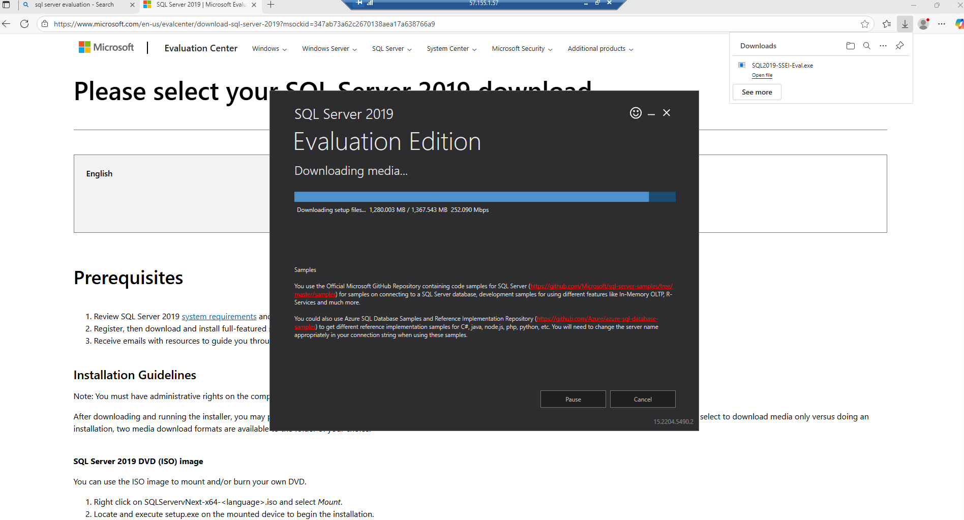

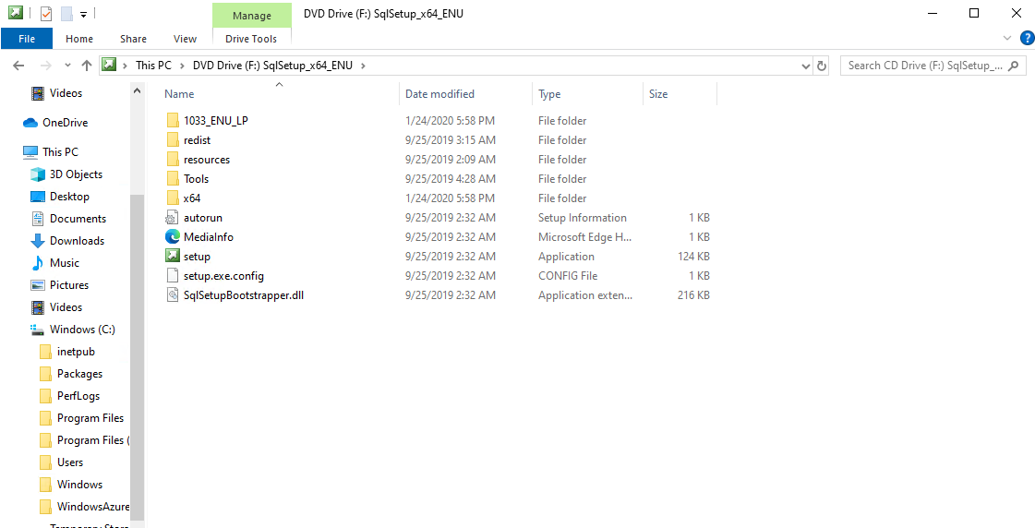

• Mount the ISO and run setup. Select 'Database Engine Services' and choose Mixed Mode authentication (create 'sa' user with password).

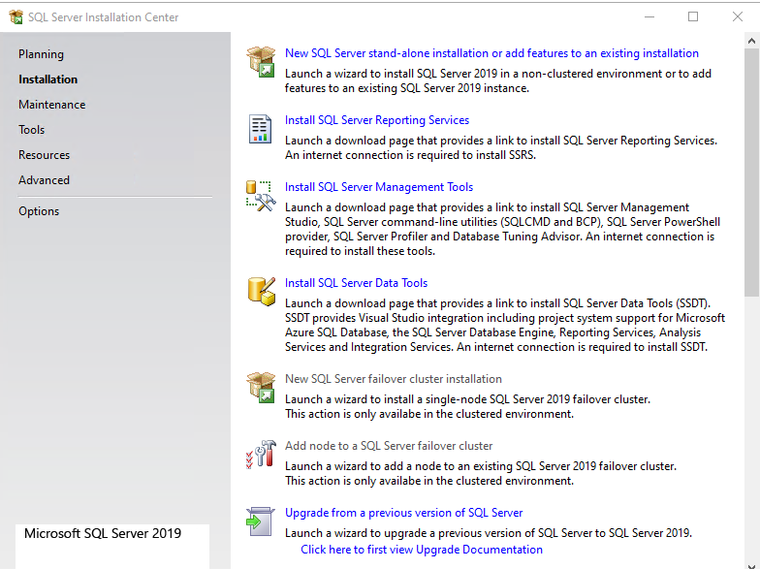

Click New SQL server stand-alone installation

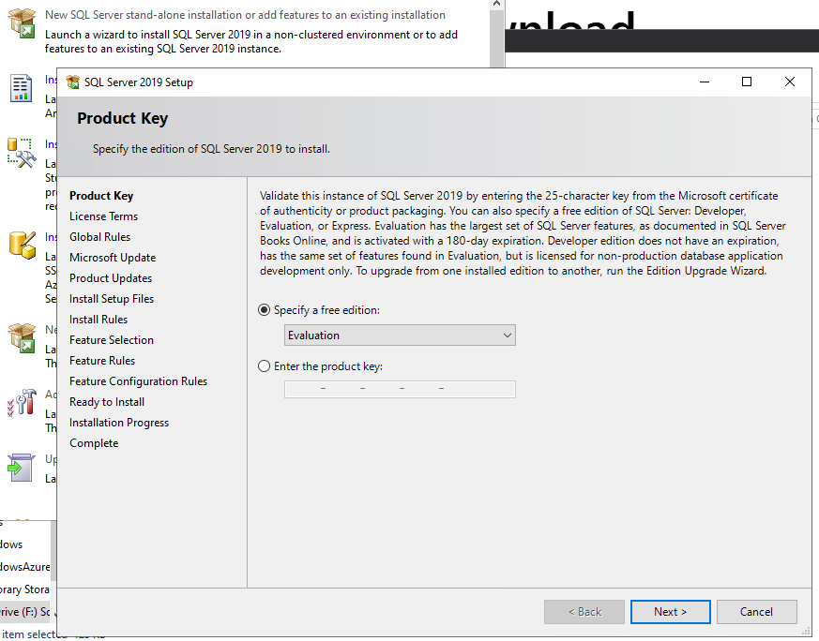

Click next

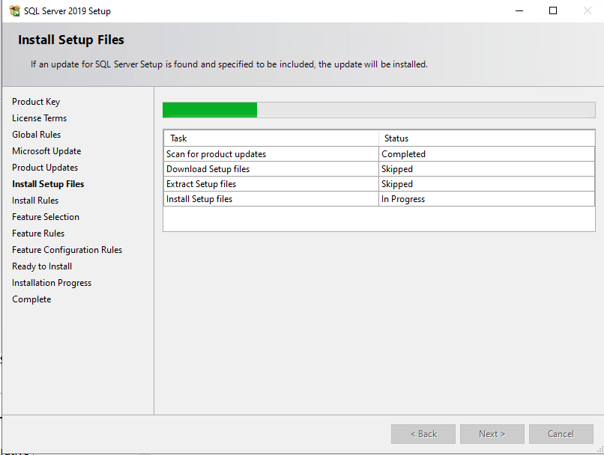

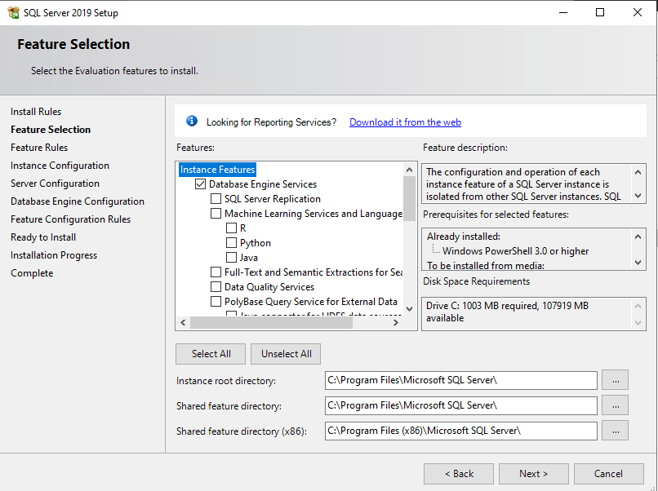

Click database engine services

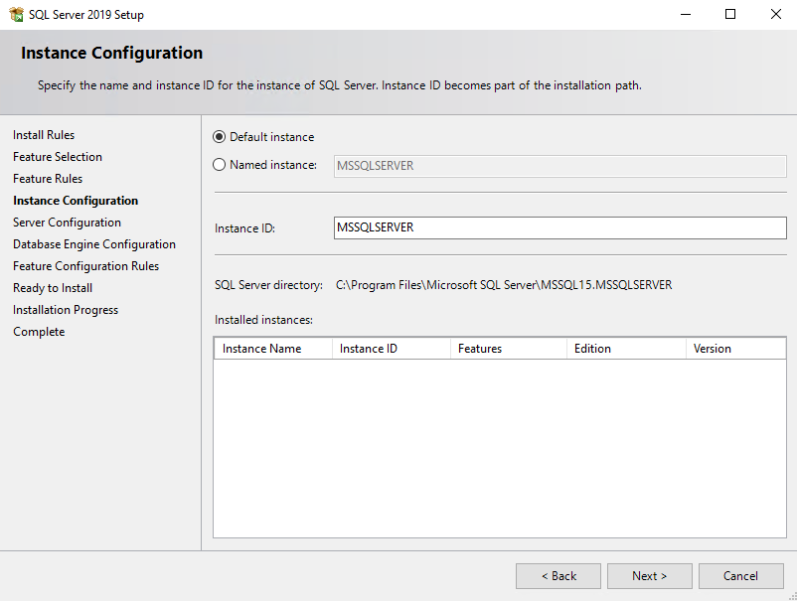

Setup your server’s name

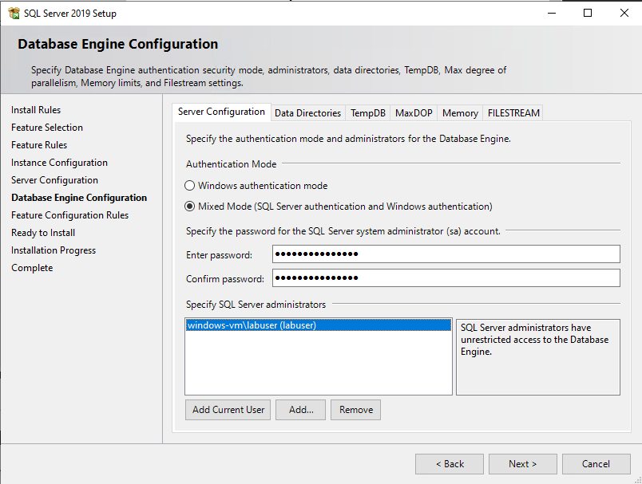

Setup your password

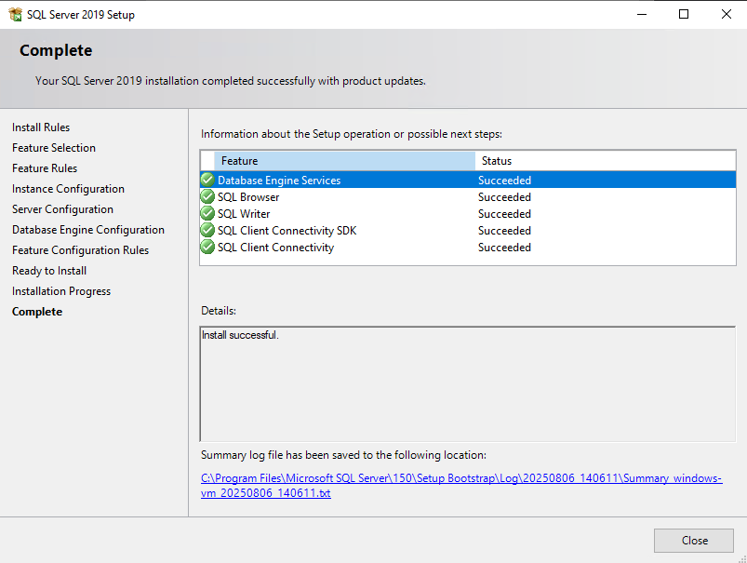

Finished installation

### Install SQL Server Management Studio (SSMS)

• Install SSMS to manage and test the SQL Server.

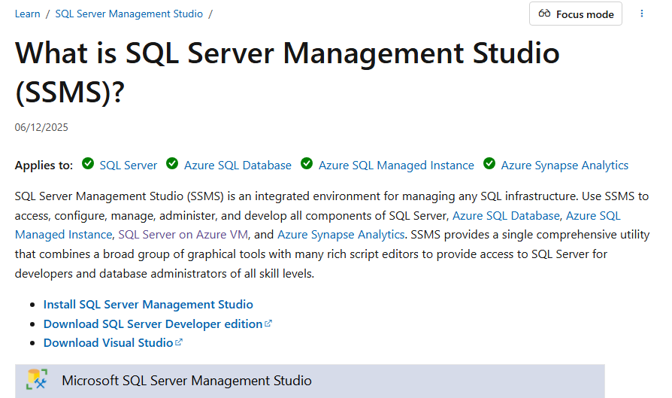

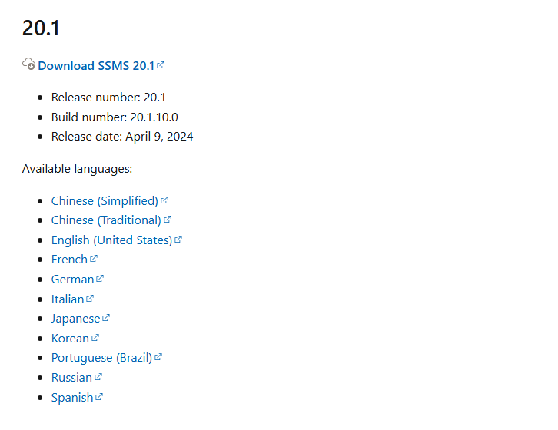

SSMS version 20.1

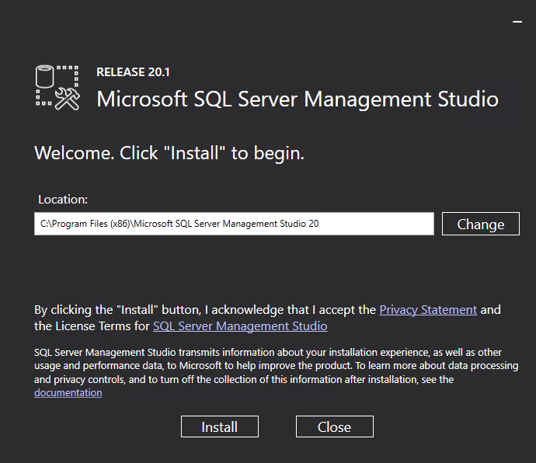

Restart the Remote Desktop Connection after installation

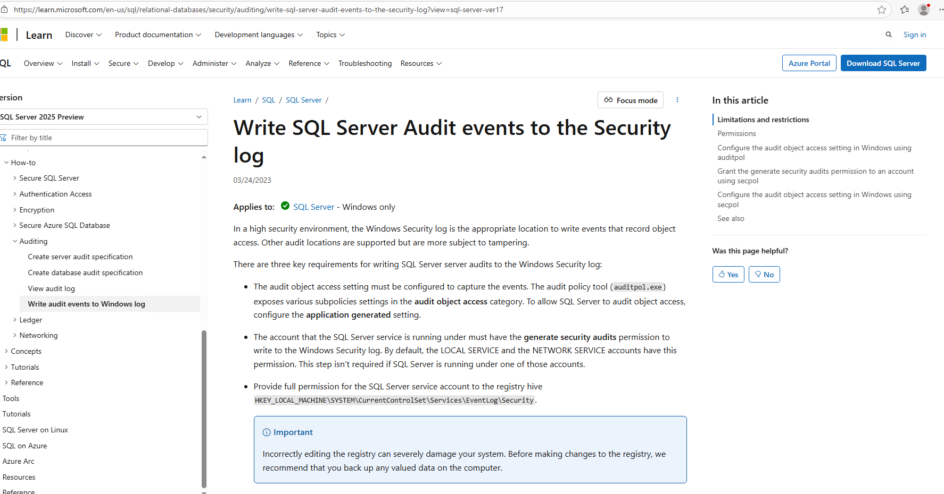

Go to this link: <https://learn.microsoft.com/en-us/sql/relational-databases/security/auditing/write-sql-server-audit-events-to-the-security-log?view=sql-server-ver16>

Copy this and paste into registry editor so our event viewer can read the log

|  |
| --- |
| **HKEY_LOCAL_MACHINE\SYSTEM\CurrentControlSet\Services\EventLog\Security** |

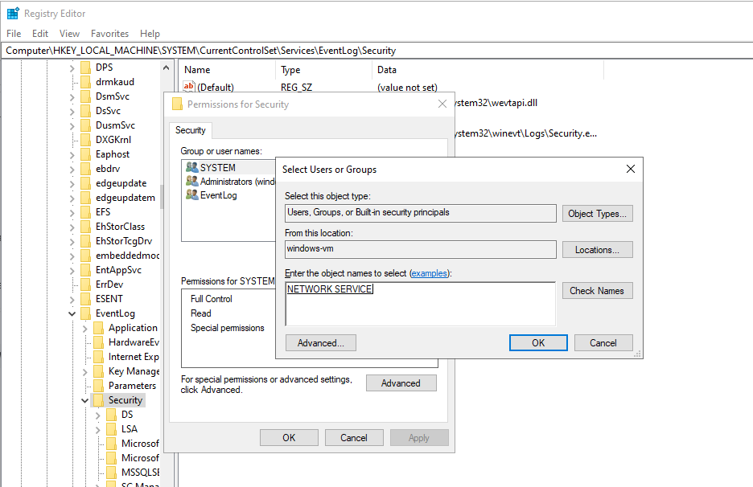

Add NETWORK SERVICE

1. Go to security
2. Right click
3. Go to permissions
4. Add NETWORK SERVICES
5. Set permissions

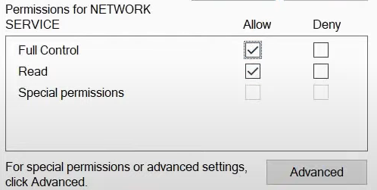

Permissions for network service

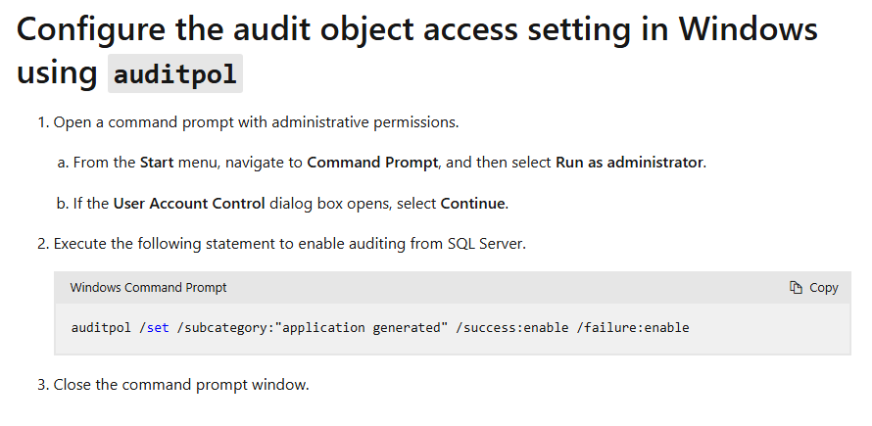

Configure audit object access

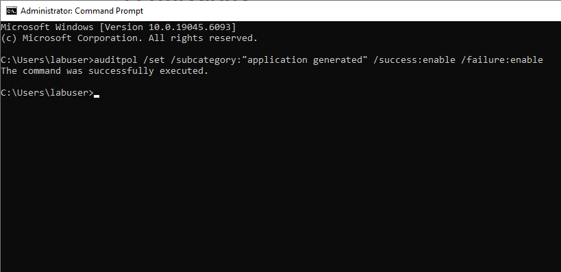

Copy and paste the Windows Command Prompt

* This following statement to enable auditing from SQL Server

|  |
| --- |
| auditpol /set /subcategory:"application generated" /success:enable /failure:enable |

• In SSMS, enable auditing: set Login Auditing to record both failed and successful logins.

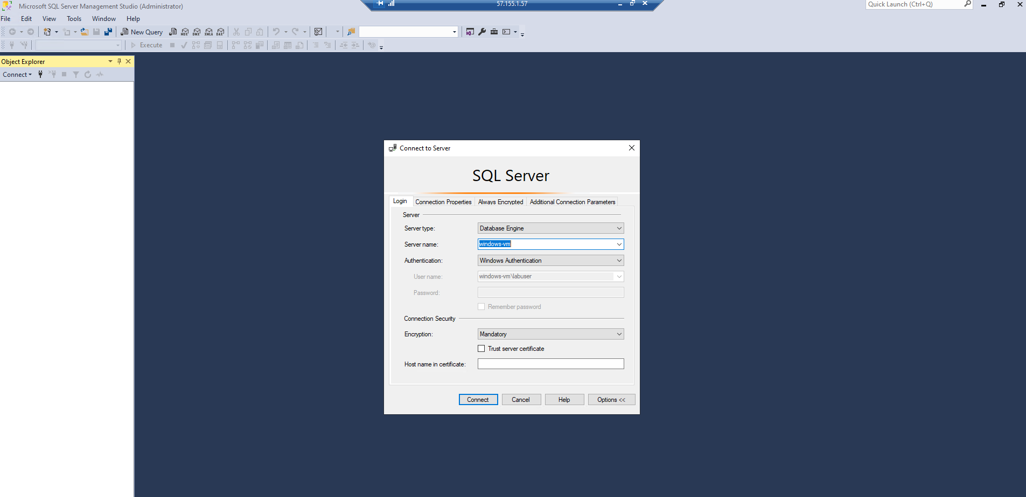

Click windows sql server authentication

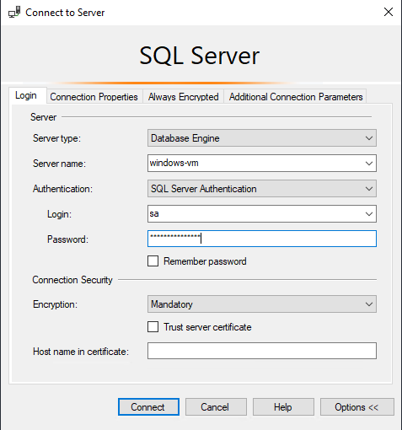

Login with your password (use sa for login name)

1. Click windows-vm (SQL Server….) at the top
2. Click security
3. Select both failed and successful logins to generate logs

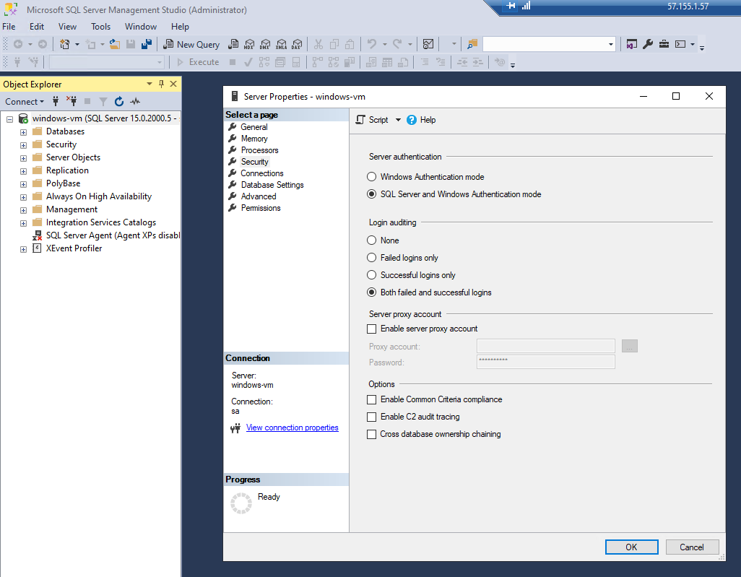

Server Properties

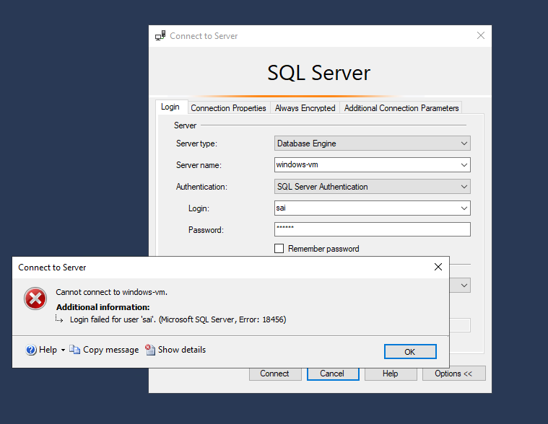

Failed attempts to get the logs

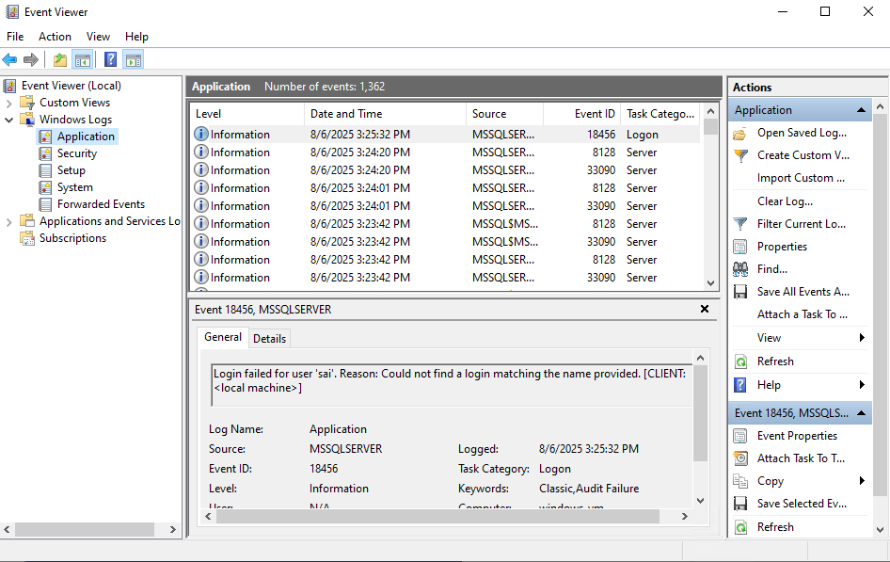

Event viewer log for login failed

* We can see the failed login attempt for user sai instead of sa

### Access Linux VM via SSH

• From the Windows host, SSH into the Linux VM using: ssh labuser@<Linux_VM_PublicIP>

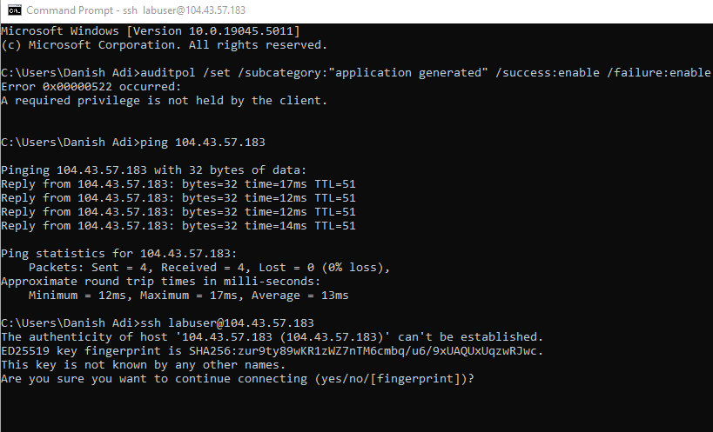

SSH login for linux

* Click yes after the input the command

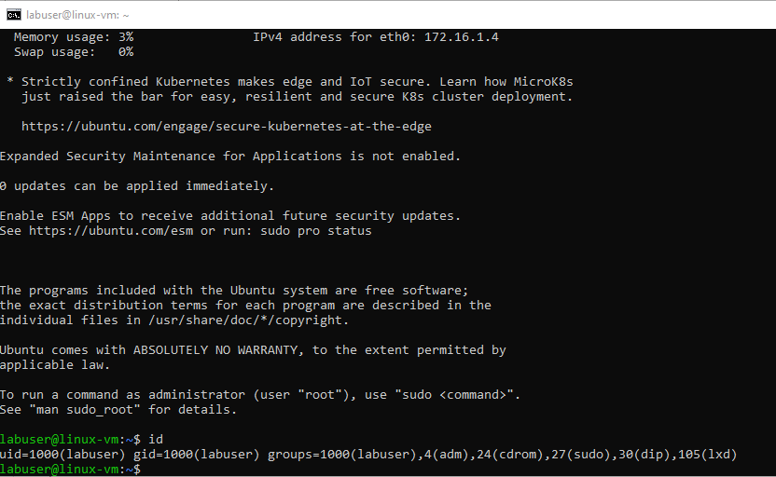

Linux vm connected

### Setup Attacker VM

• Create a separate Resource Group 'RG-attacker'. Deploy attacker-vm (Windows) in a different region to simulate an external attacker.

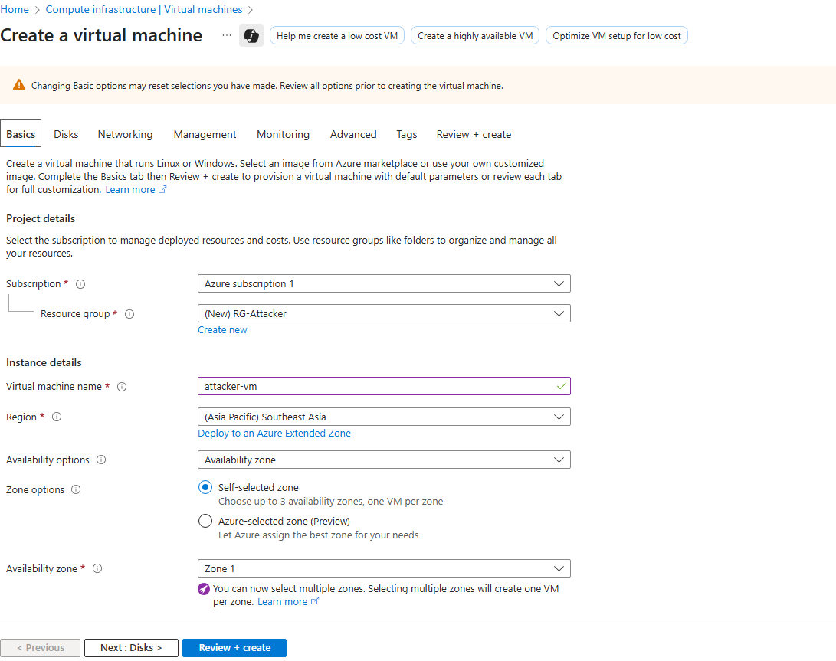

Attacker vm setup

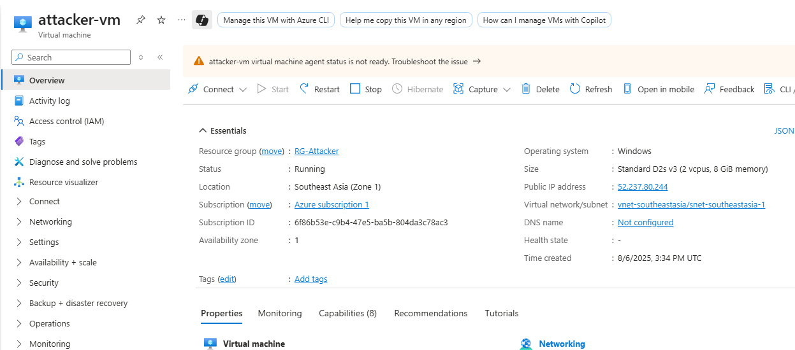

Copy the ip of the attacker vm

• From Attacker-VM, attempt RDP/SSMS/SSH failed logins using gibberish usernames (e.g., 'danish') to generate logs. SSMS is installed on the attacker VM to generate failed login attempts for the SQL server as well.

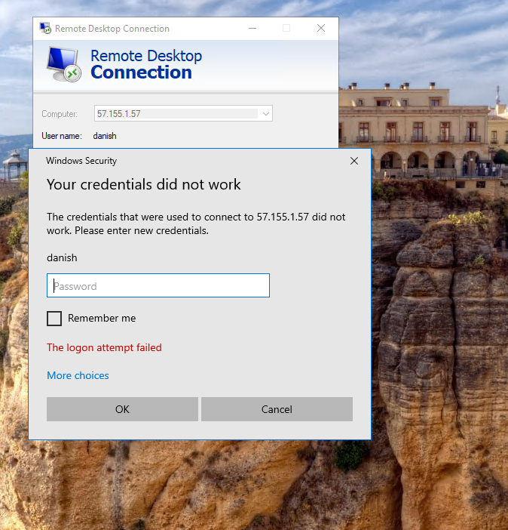

Attack windows vm

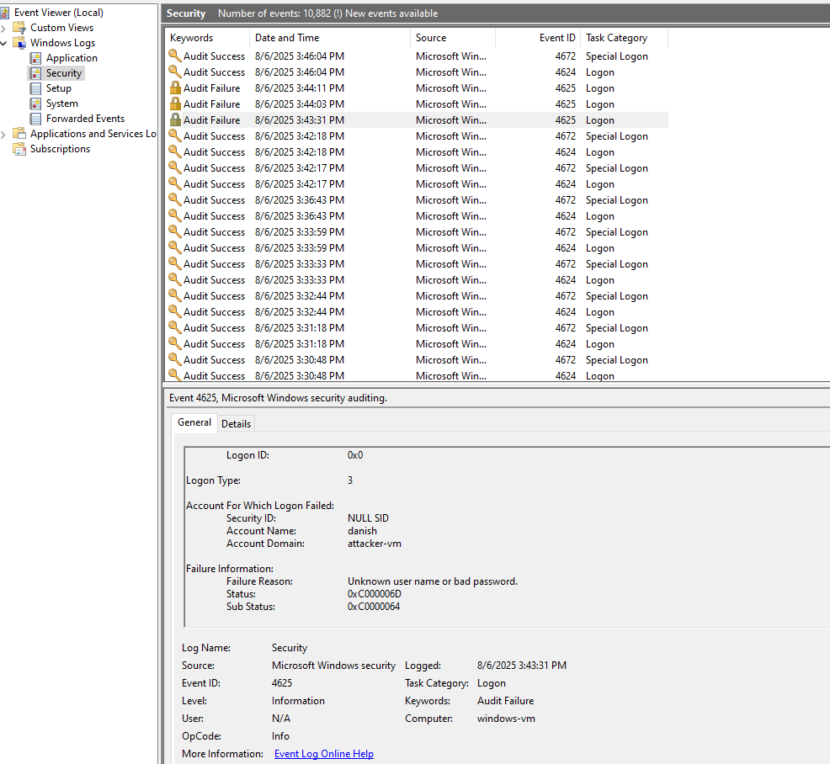

Audit failure for user ‘danish’

* Attack SQL server to generate some logs

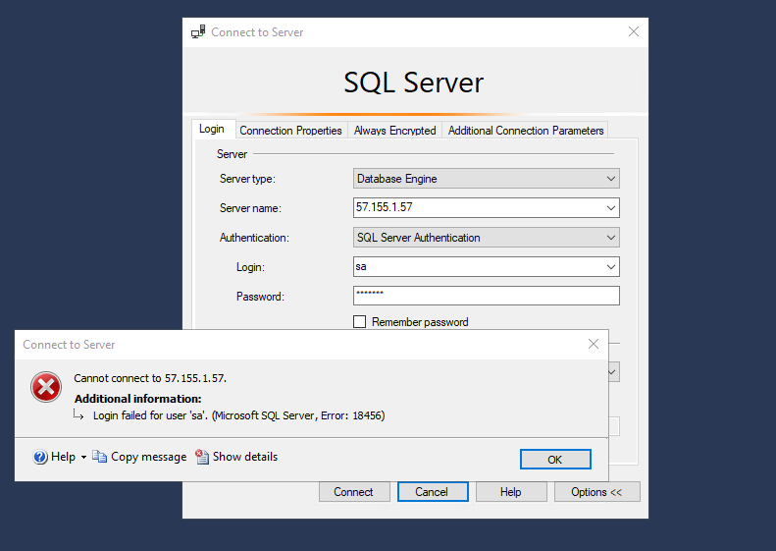

Create failed attempt connect to server

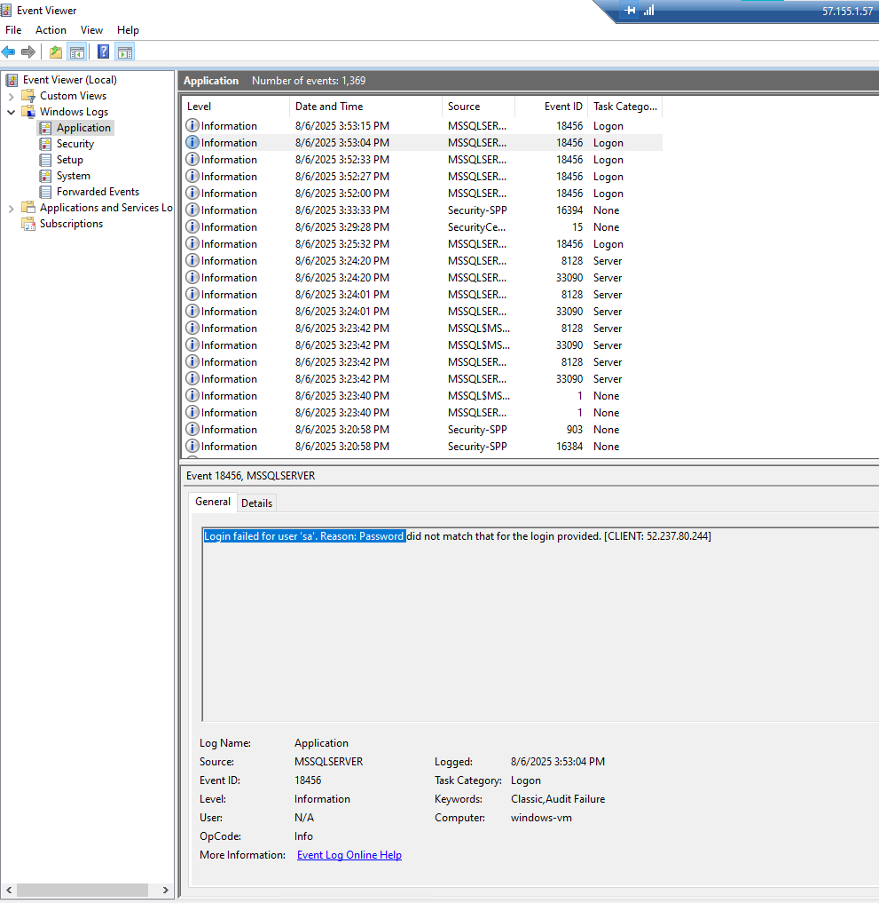

Login failed for SQL Server

* To generate logs for linux open PowerShell Command used on the attacker VM to attempt an SSH login to the Linux VM with the whatever username example ‘ssh admin@yourwindowsvmipaddress’

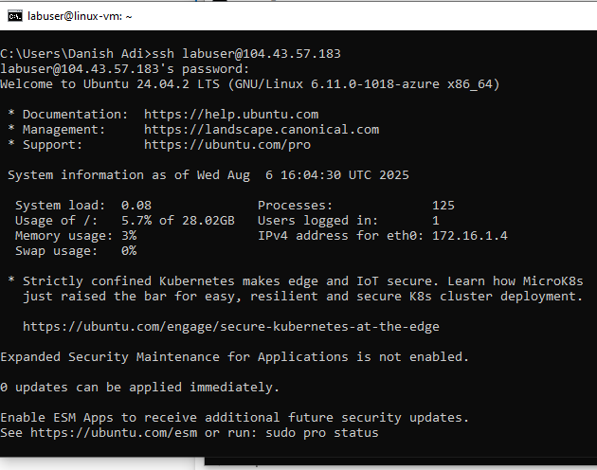

Login to Linux vm to observe the logs

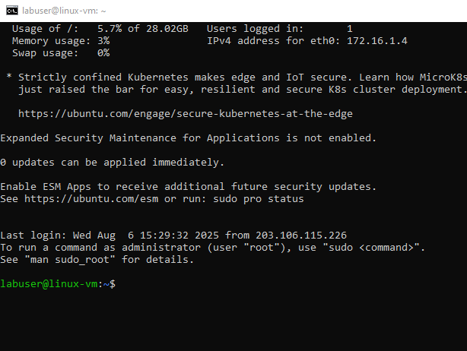

Successful login to linux

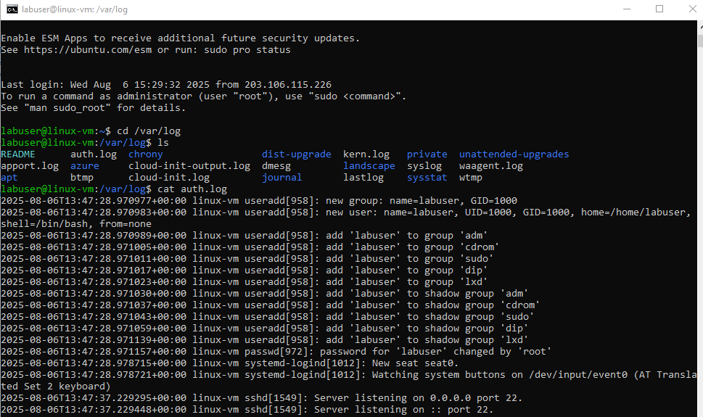

Go to cd /var/log > ls > cat auth.log

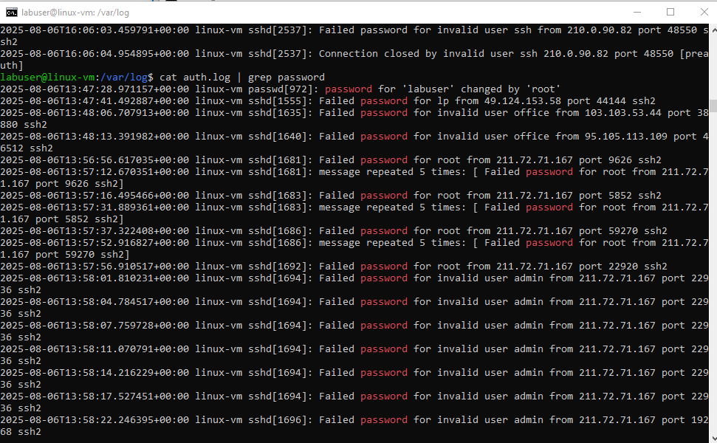

Cat auth.log | grep password to see output for failed password

* We can see that our linux machine is vulnerable and so many attackers try to connect to our linux vm machine.

## Phase 3 — Log Collection & Analytics Setup

### Create Log Analytics Workspace

• Create workspace 'LAW-RG' in RG-lab and attach necessary data sources.

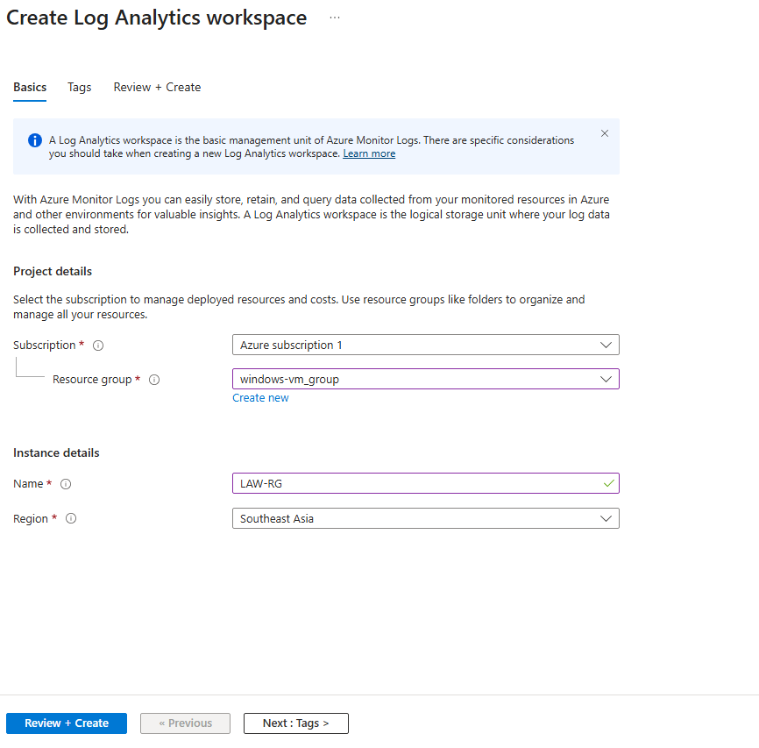

Create Log Analytics Workspace

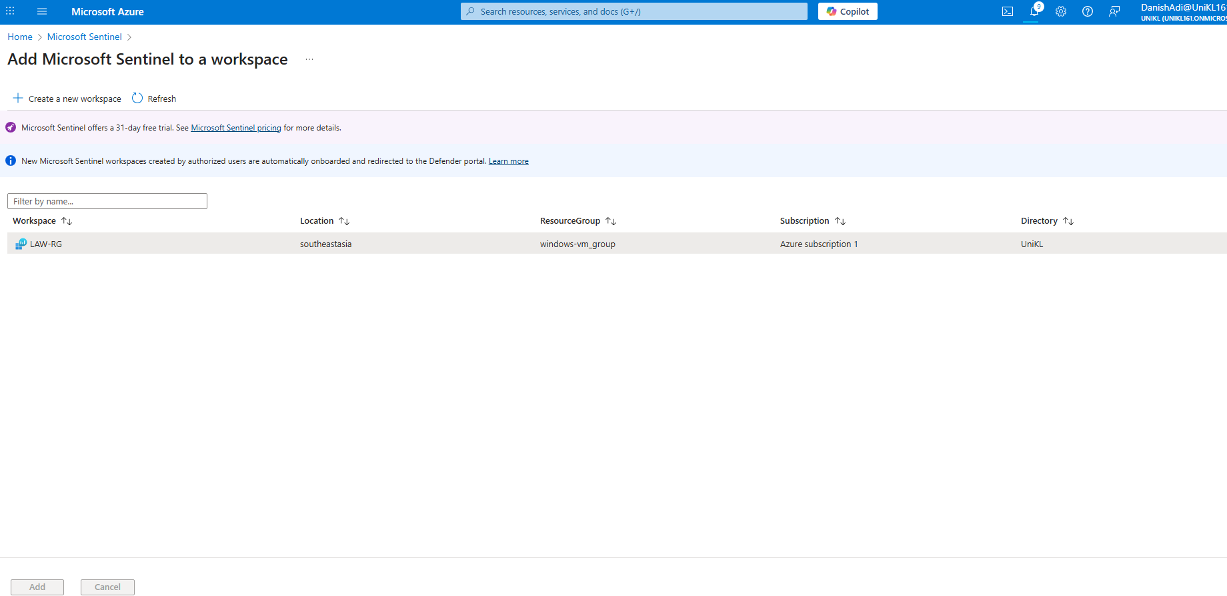

Add Microsoft sentinel to a workspace

### Deploy Microsoft Sentinel

• Enable Microsoft Sentinel on the Log Analytics workspace. Navigate to watchlist and create new watchlist.

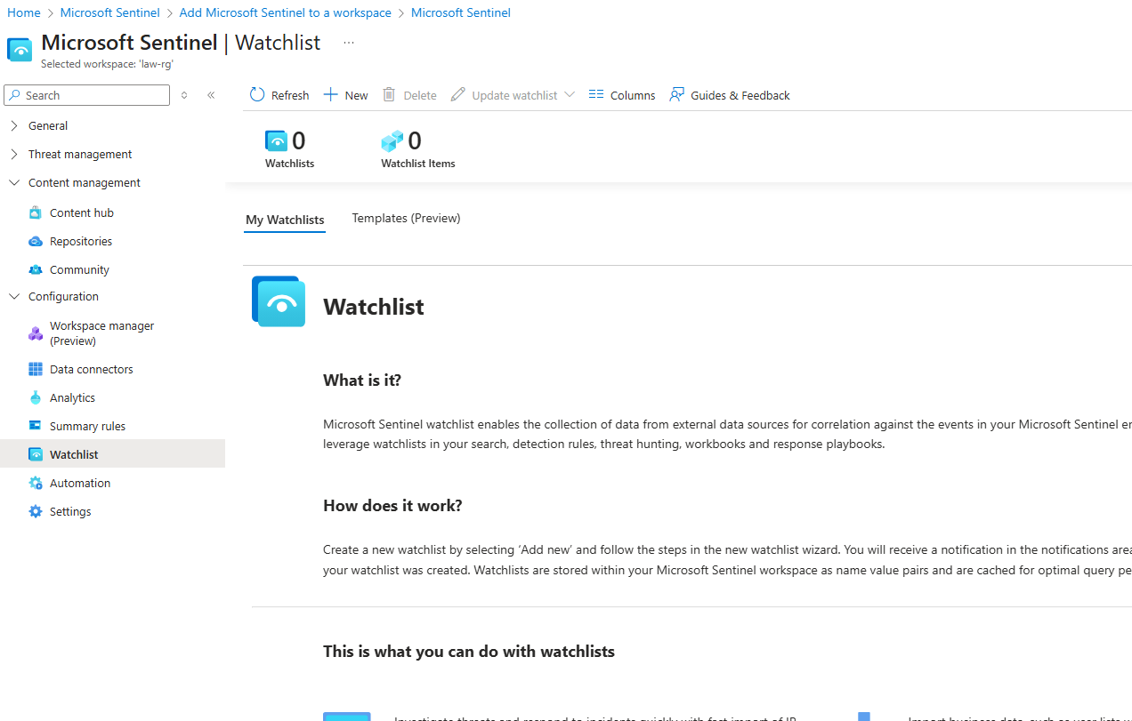

### Import GeoIP Watchlist

• Import the provided GeoIP summarized CSV into Sentinel Watchlists and name it 'GeoIP' (used for attack mapping).

• Make sure to put ‘geoip’ otherwise it will not work

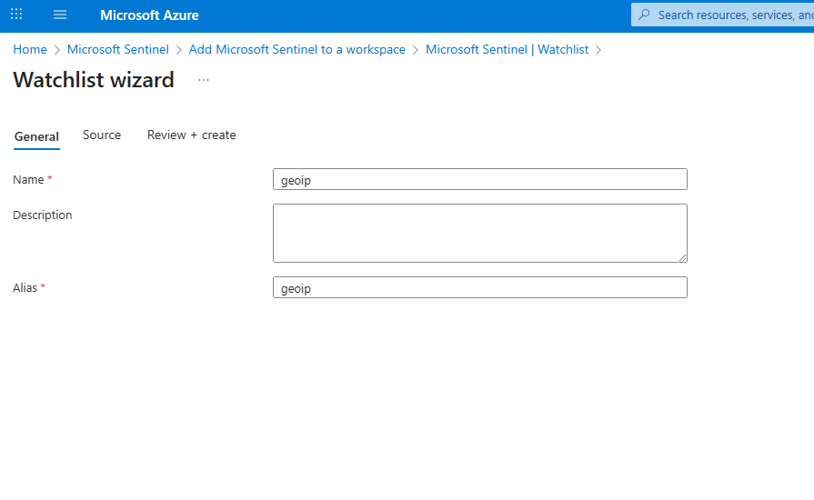

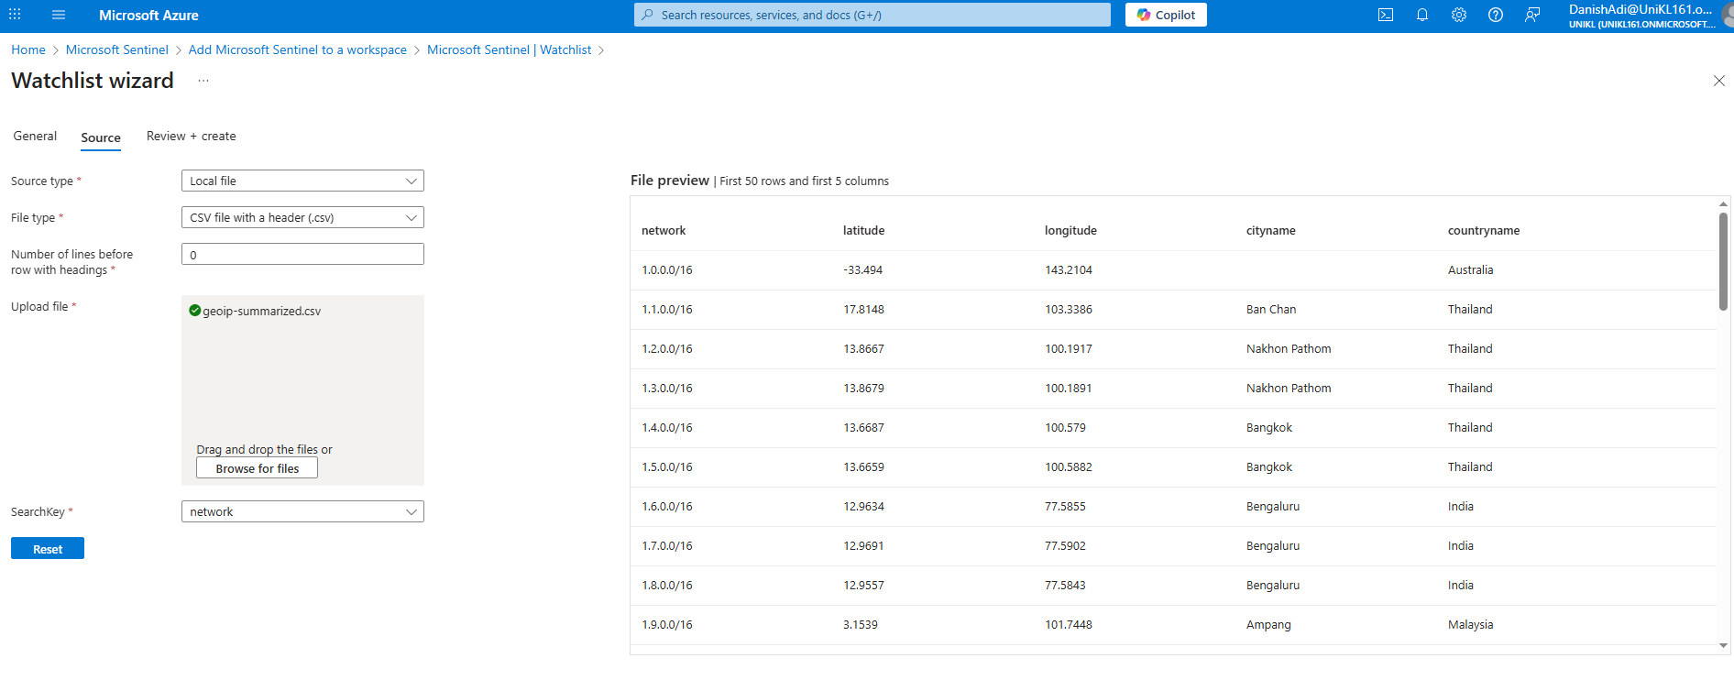

Select provided csv file

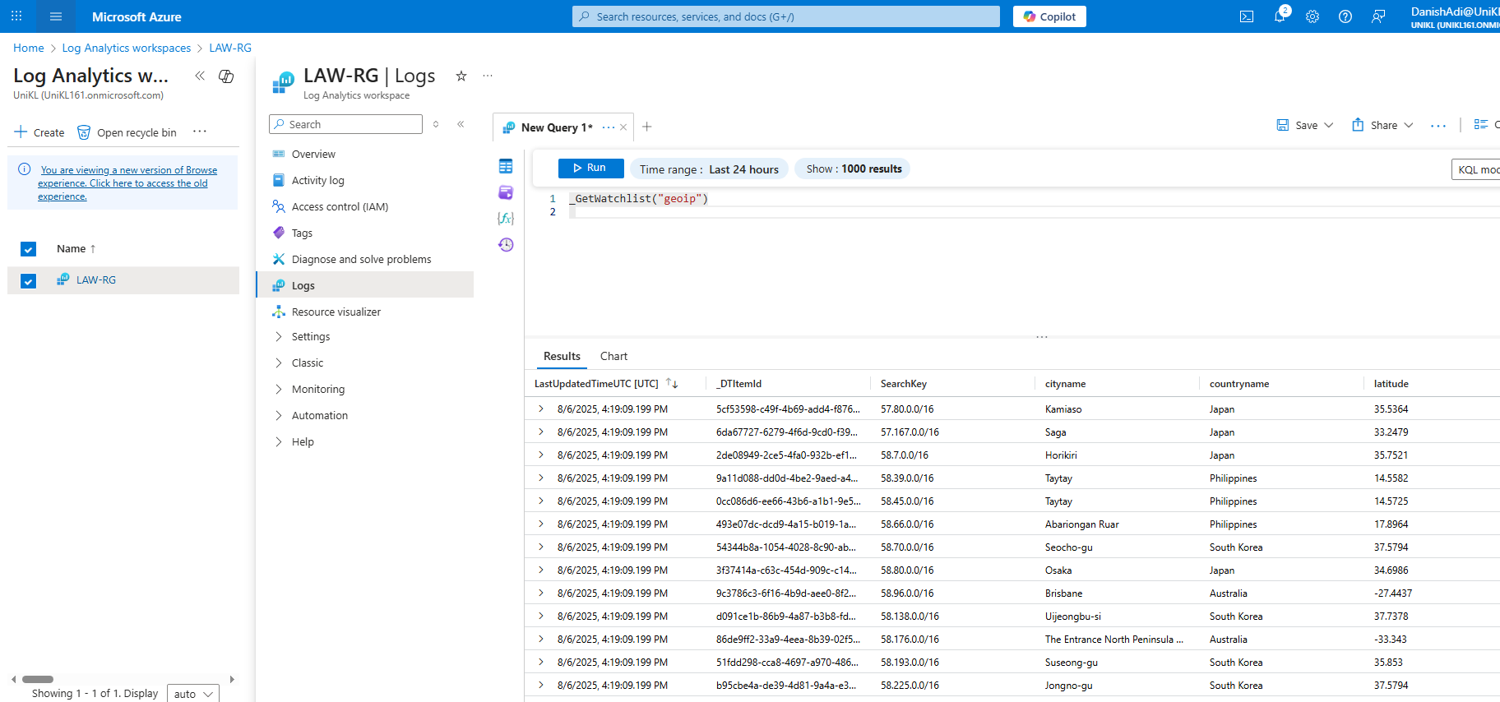

Query _GetWactchList(“geoip”)

### Enable Microsoft Defender for Cloud & Data Collection

• Enable Defender plans for Servers and SQL. Turn on 'All Events' data collection to Forward security events to Log Analytics.

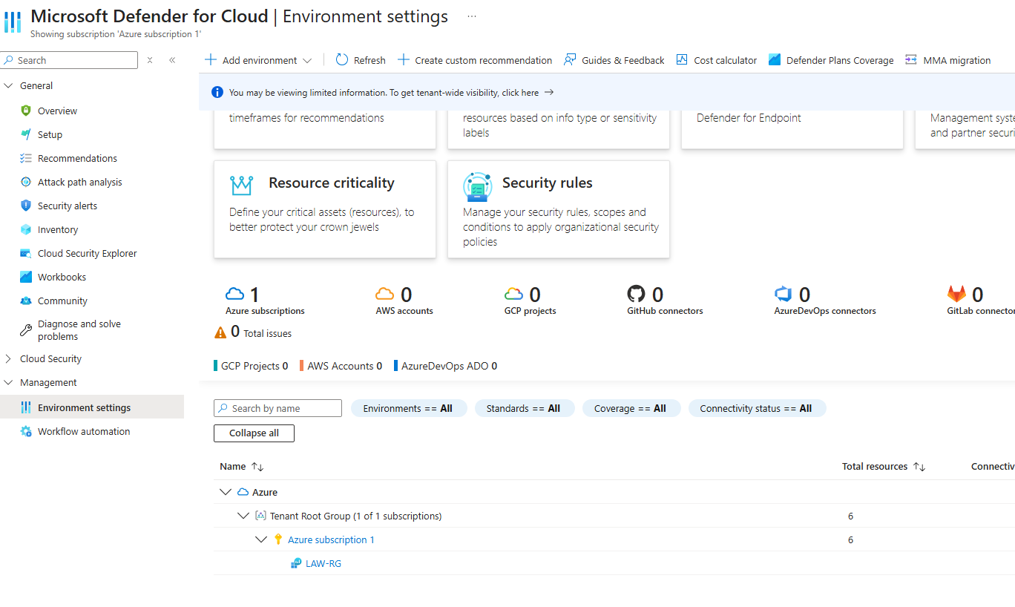

Click LAW-RG

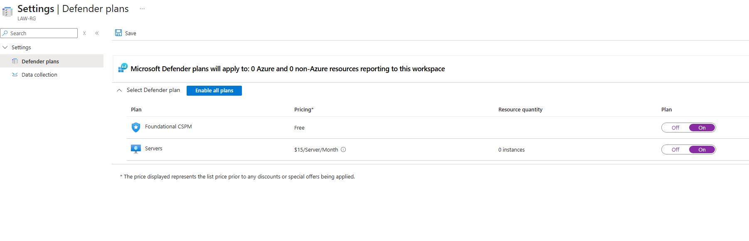

Select on for Servers

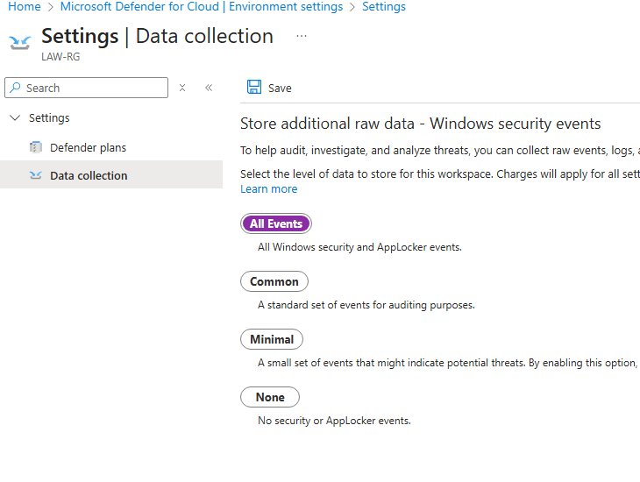

Click on all events

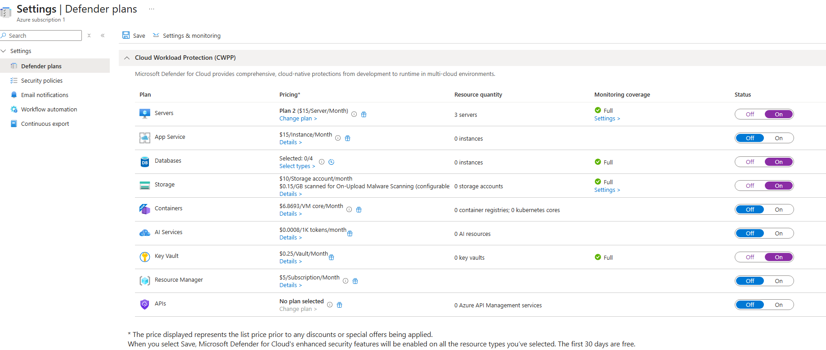

Click one for Servers, Databases, Storage, Containers, Key Vault

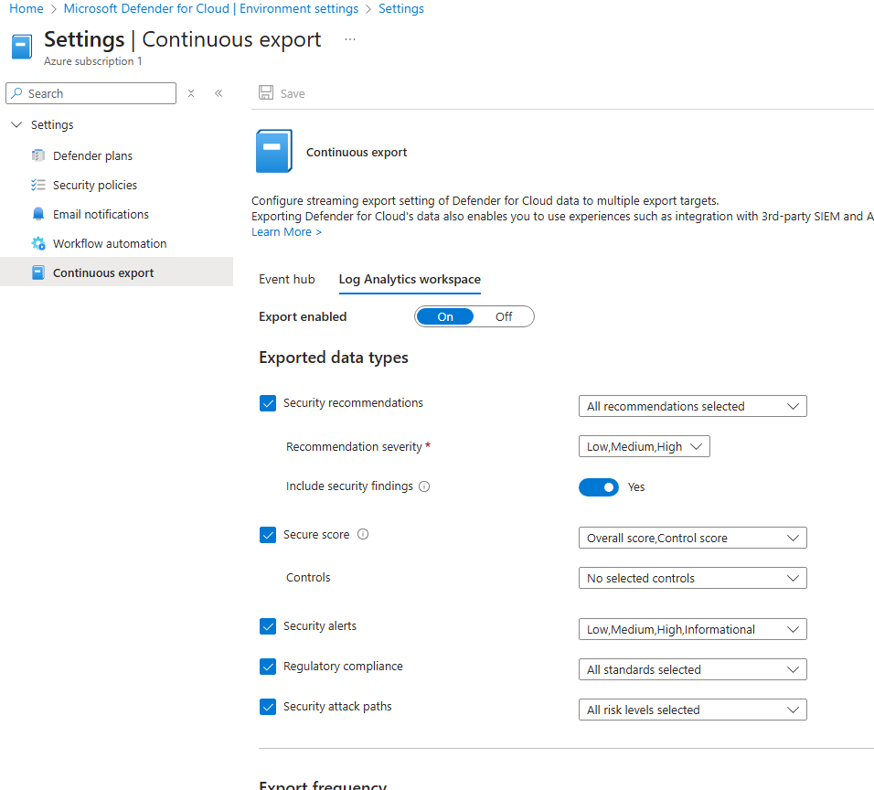

Create continuous export

1. Go to Microsoft Defender for Cloud > Environment settings > settings
2. Select Log Analytics workspace and select all the data types

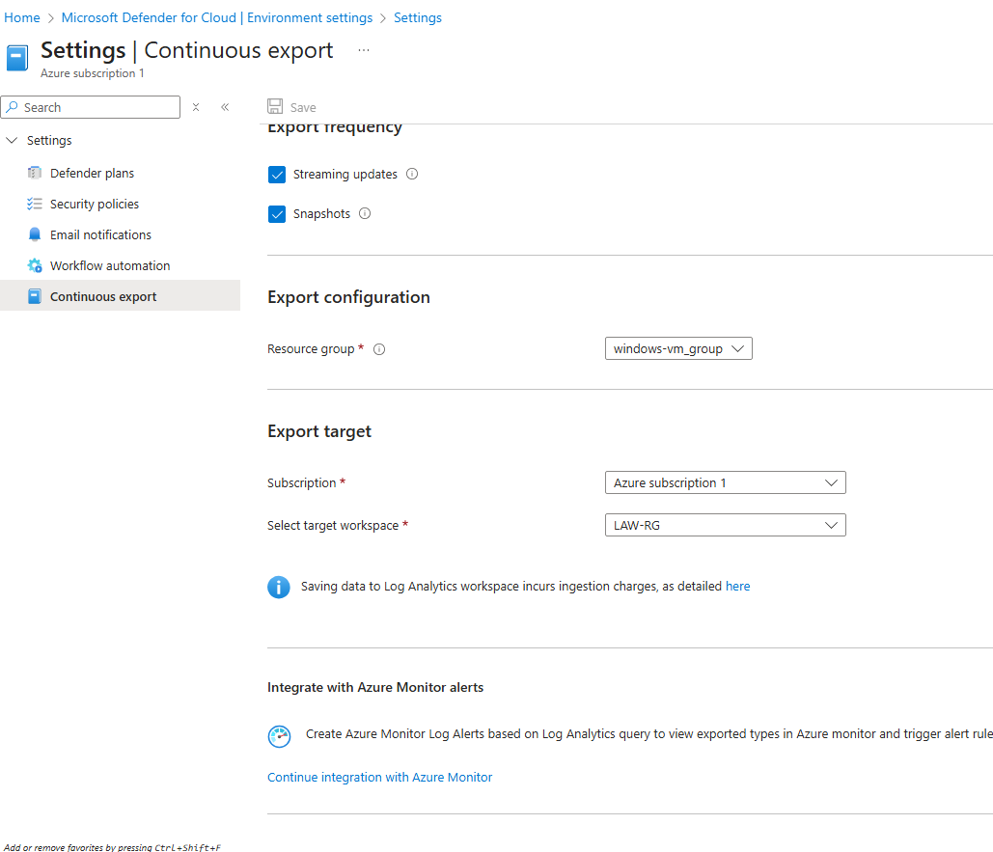

Select target workspace the LAW-RG

### 13. Enable NSG Flow Logs

• Create a Storage Account for logs; enable NSG Flow Logs (Version 2) targeting that storage account and enable Traffic Analytics.

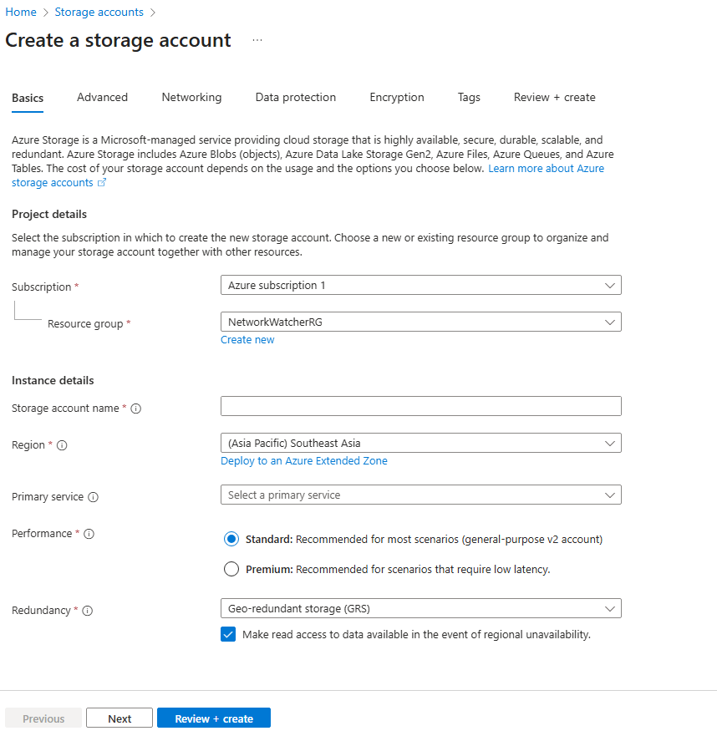

Create a storage account

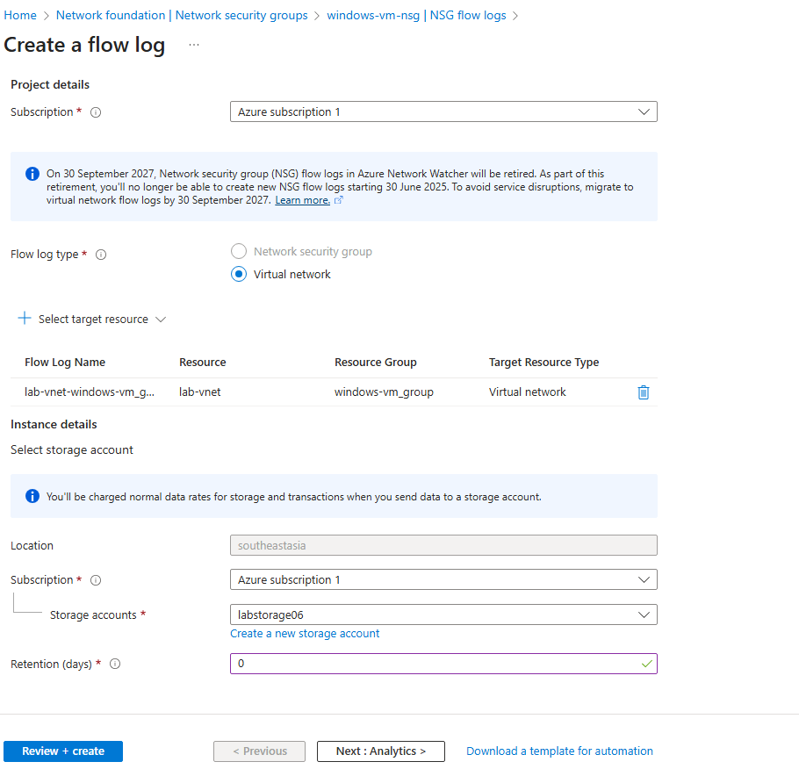

Create named storage ‘labstorage06’

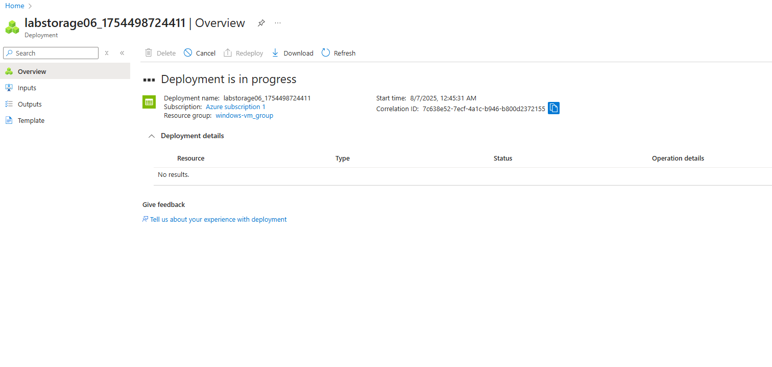

* A new storage account is being created in the same region as the other resources. NSG flow logs for both the Windows and Linux VMs are enabled and configured to send traffic data to this storage account.
* Go to Network Security Group and click for windows vm

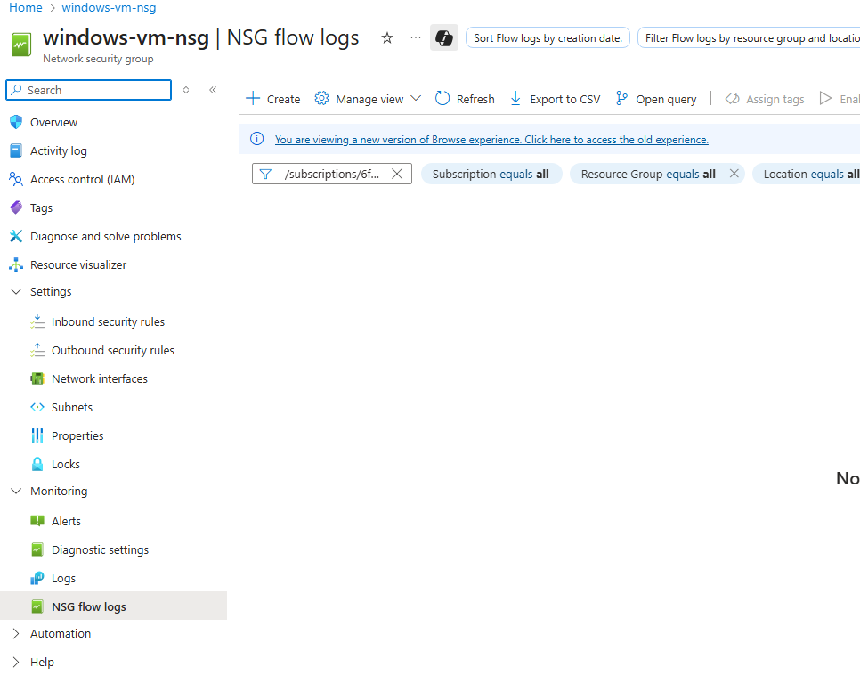

Click create to create nsg flow logs

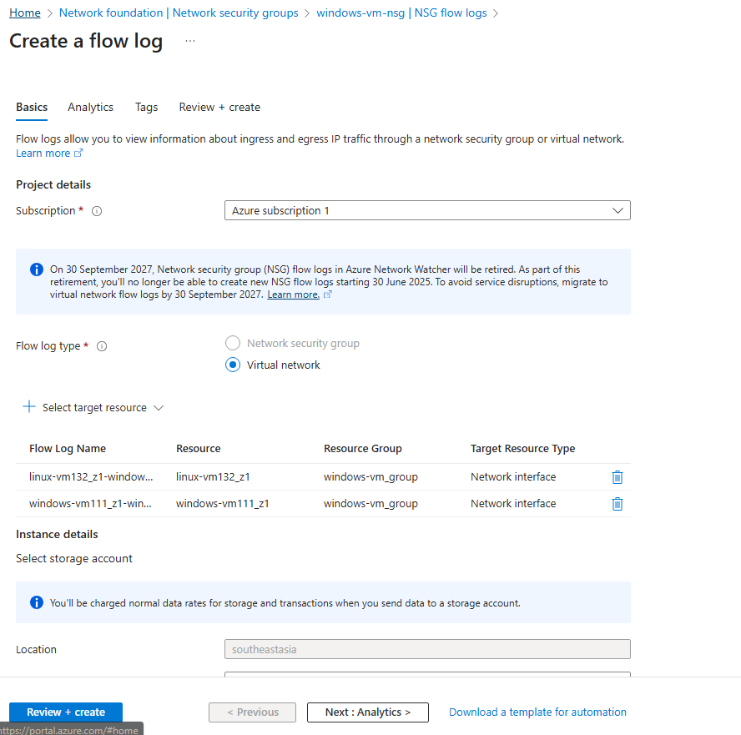

Select target resource and click linux and windows

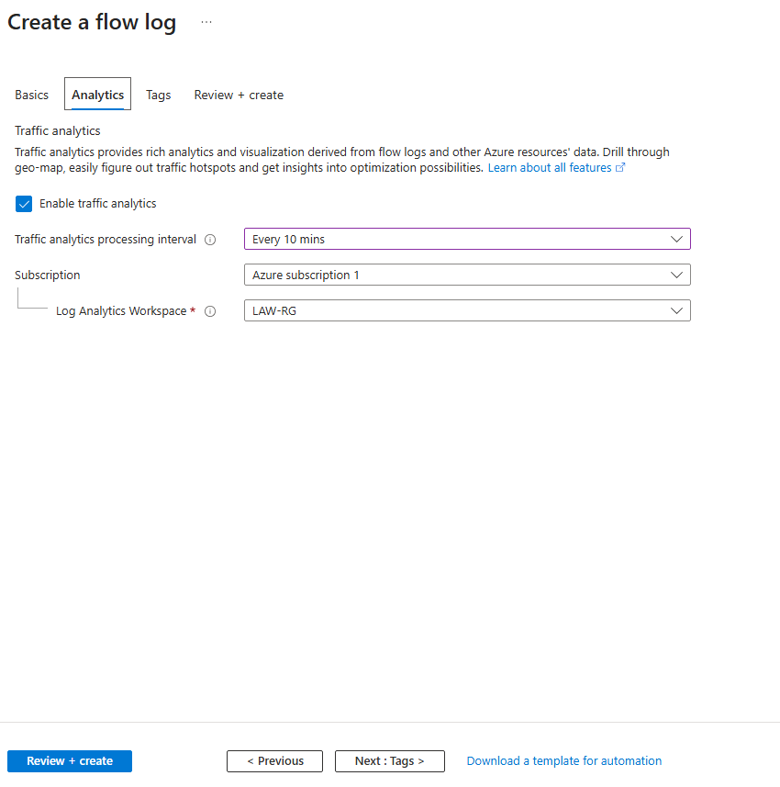

Create traffic analytics processing internals for every 10 mins

## Phase 4 — Advanced Logging & Sentinel Rules

### Set Up Data Collection Rules (DCRs)

• Create DCRs to collect Linux auth logs (e.g., /var/log/auth.log), Windows Event logs (Security), and custom logs for malware detection and firewall tampering.

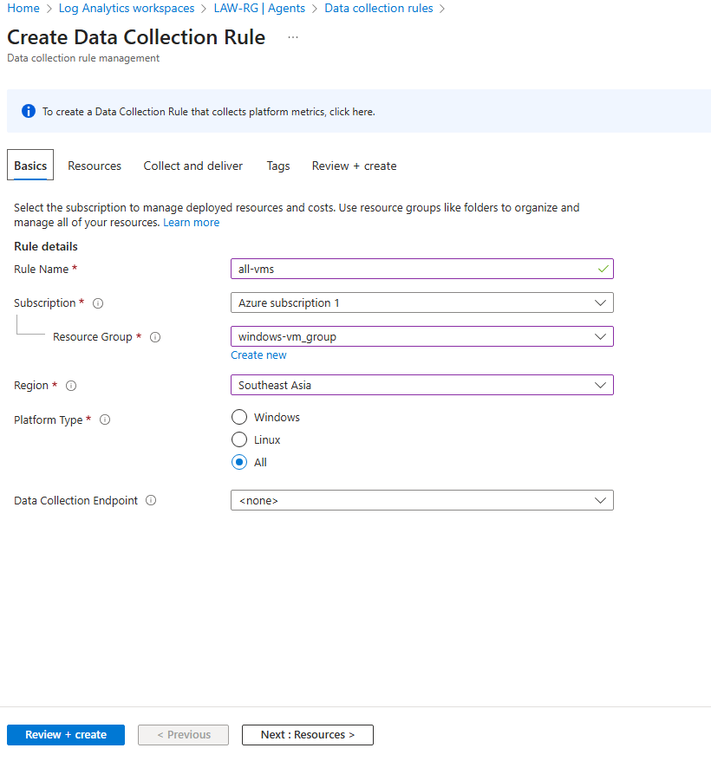

Select your resource group

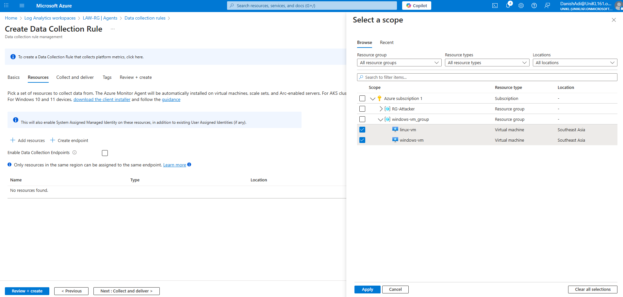

Select resources and choose linux and windows vm (not the attacker)

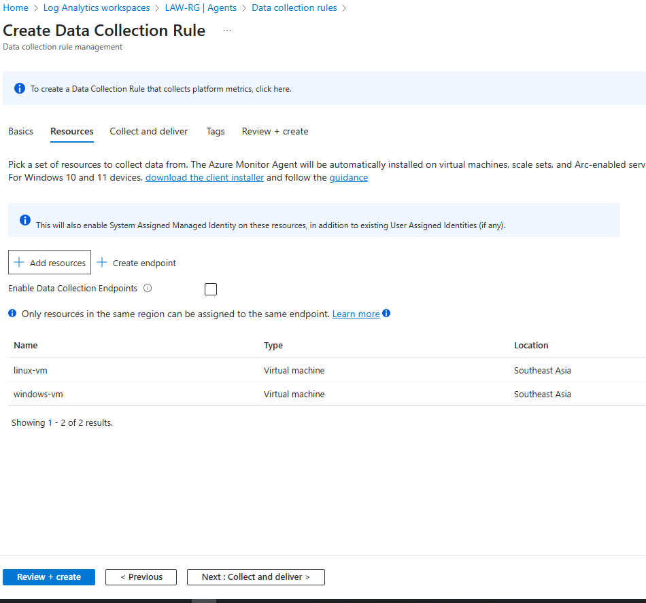

Make sure both Linux and Windows vm selected

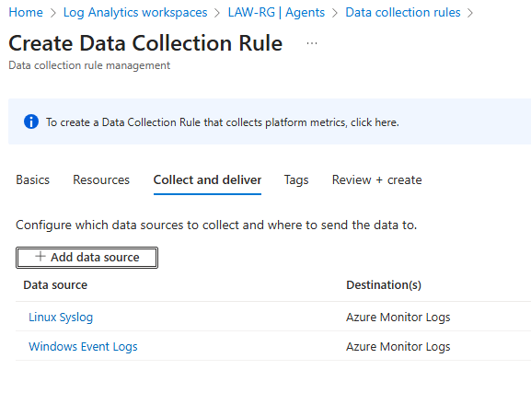

In collect and deliver add data source

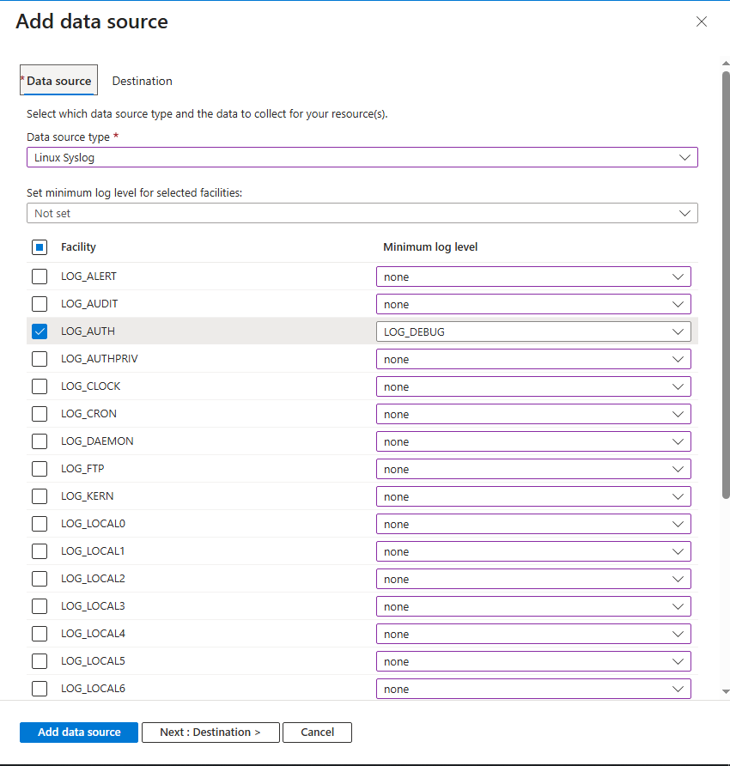

Put the name Linux Syslog and select LOG_AUTH as LOG_DEBUG (click none for the rest)

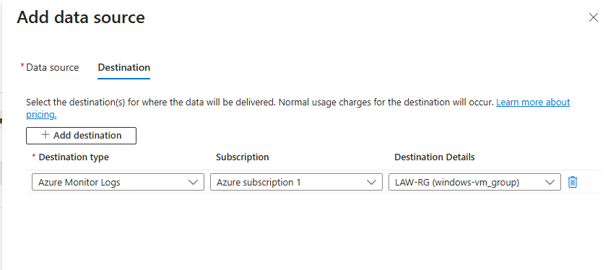

Add destination and make sure it is correct Log Analytics Workspace

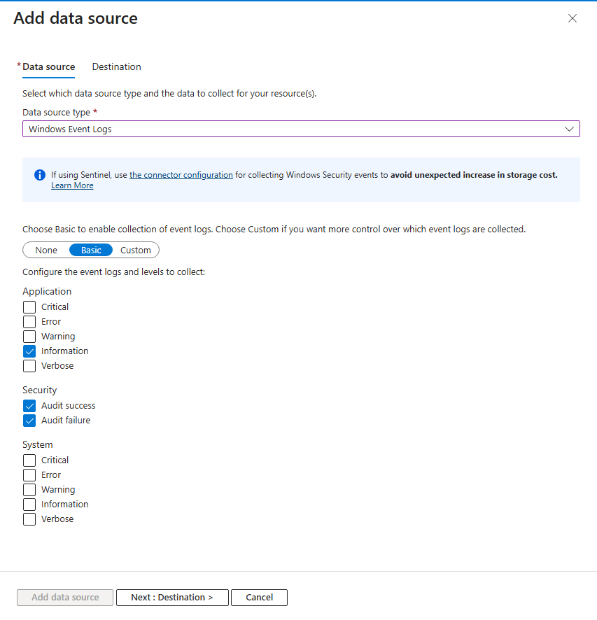

Go back and create for Windows Event Logs



Add destination and make sure it is correct Log Analytics Workspace

* Go back to log analytic workspaces > agents > data collection rules > all-vms > Data Sources > windows event logs > data source > custom

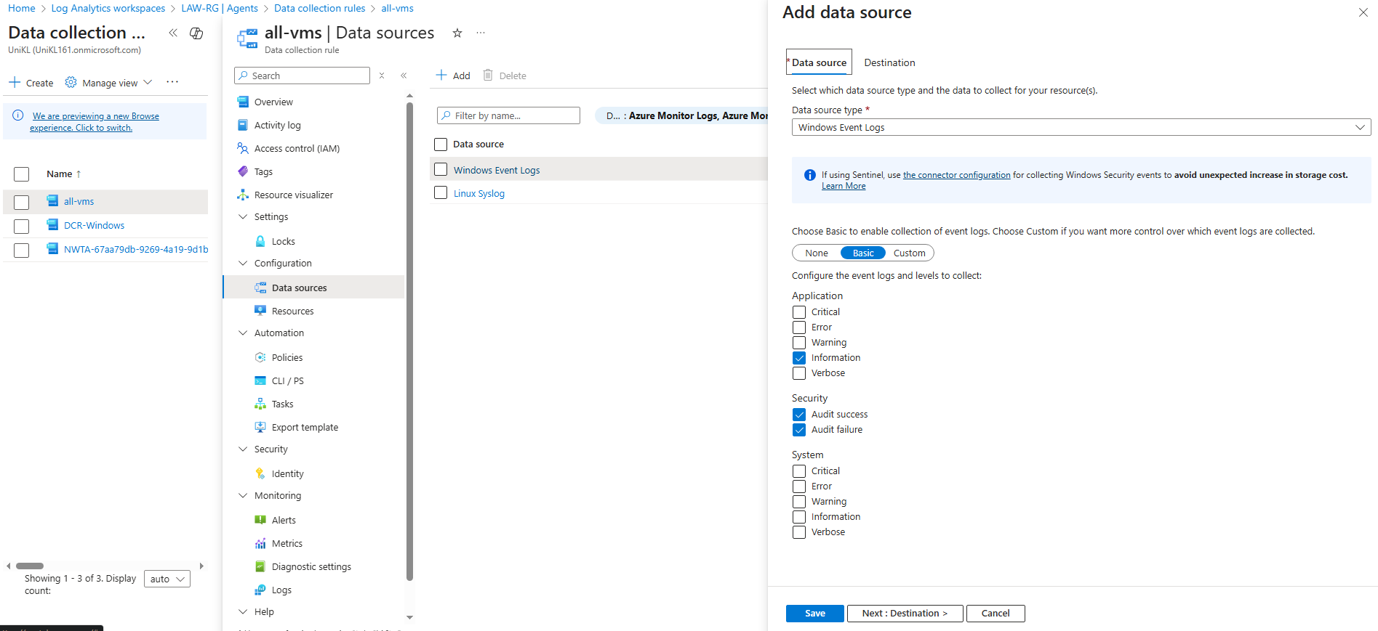

* Put this in custom queries

|  |
| --- |
| // Windows Defender Malware Detection XPath Query  Microsoft-Windows-Windows Defender/Operational!*[System[(EventID=1116 or EventID=1117)]]  // Windows Firewall Tampering Detection XPath Query  Microsoft-Windows-Windows Firewall With Advanced Security/Firewall!*[System[(EventID=2003)]] |

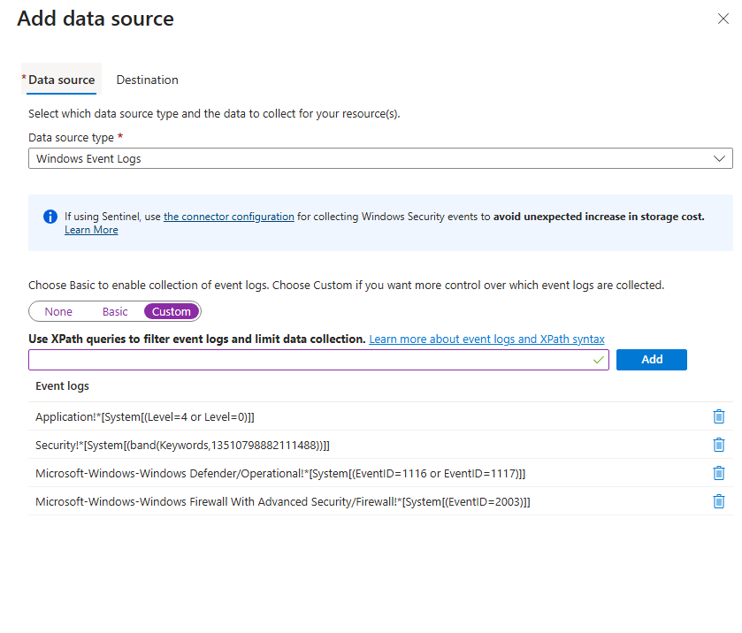

Added custom queries for malware detection and firewall tampering

* Testing log

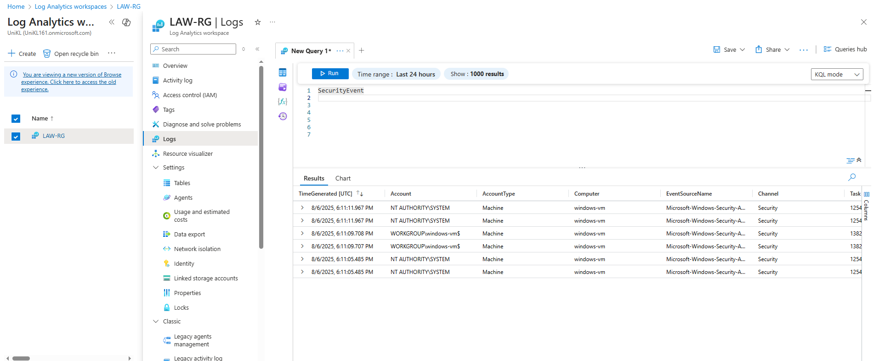

SecurityEvent KQL

### 15. Enable Diagnostic Logs for Entra ID and Subscription

• Send Entra ID sign-in and audit logs to Log Analytics.

• Export Activity Logs to Log Analytics.

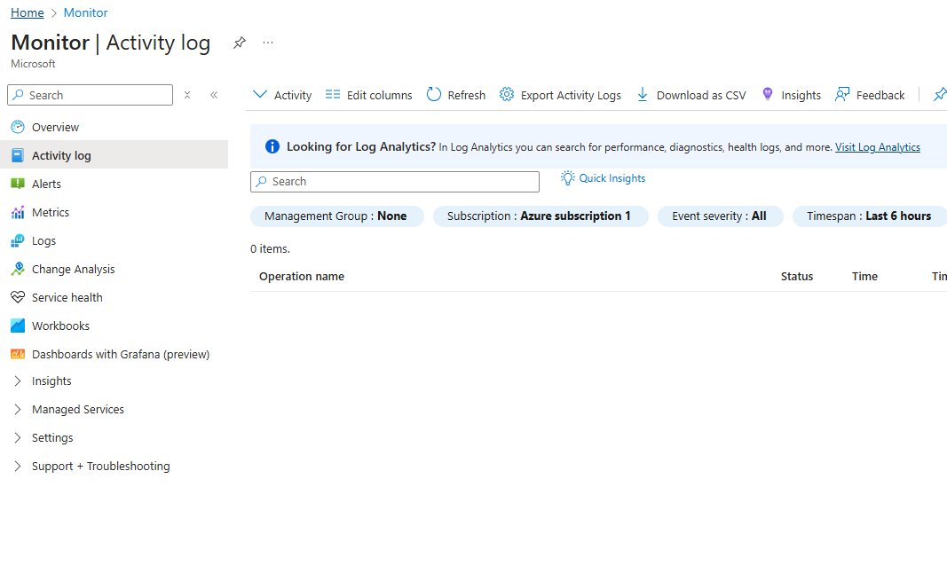

Export Activity Logs

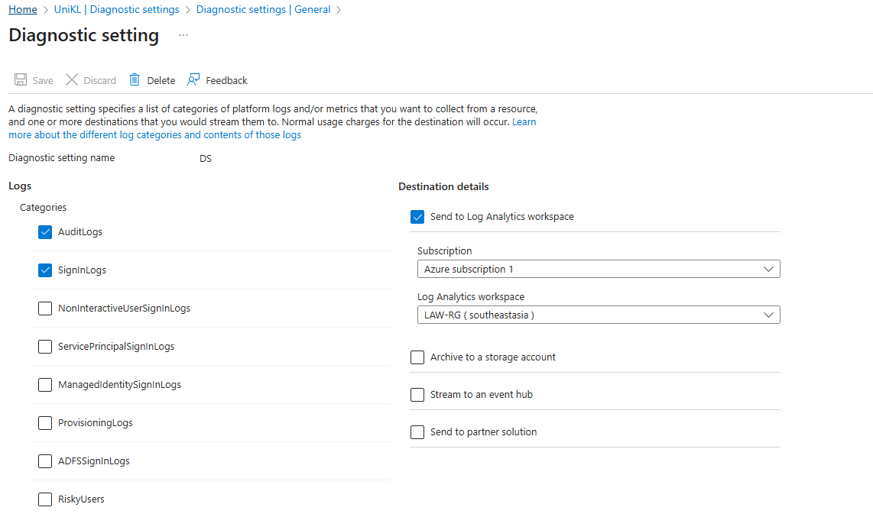

Diagnostic setting creation

### 16. Generate Logs and Test

• Create test users, fail sign-in attempts, interact with Key Vault and Storage account to produce logs.

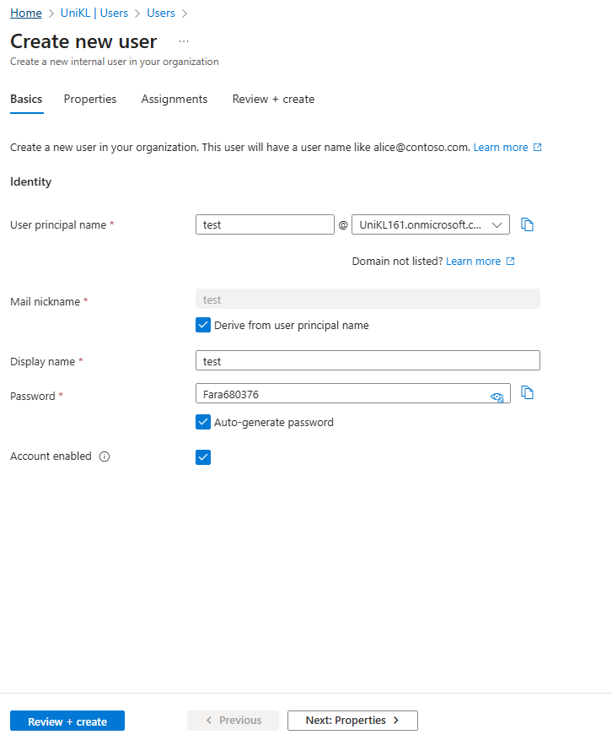

Create new user

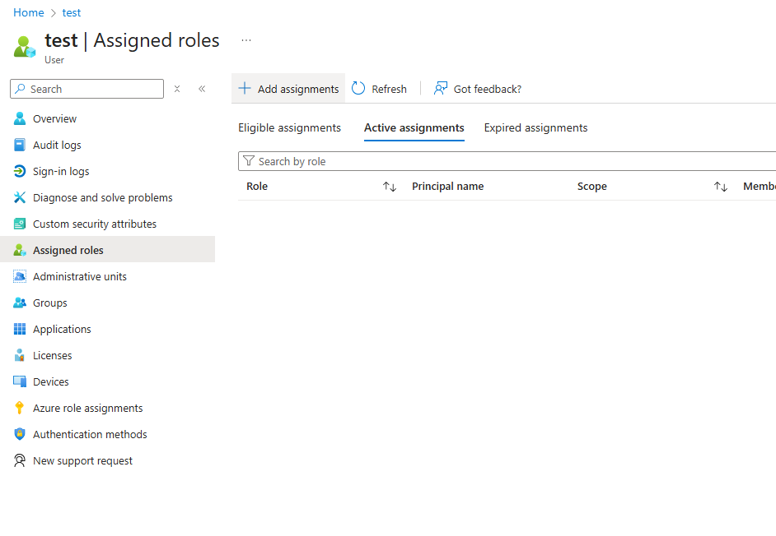

Create assignments

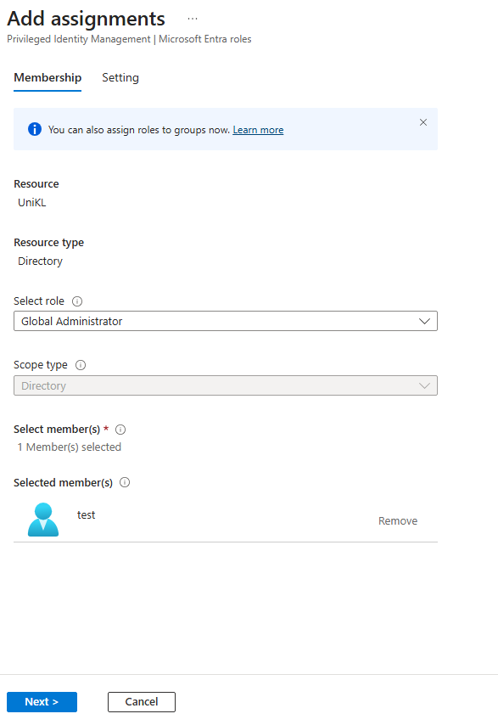

Add global administrator

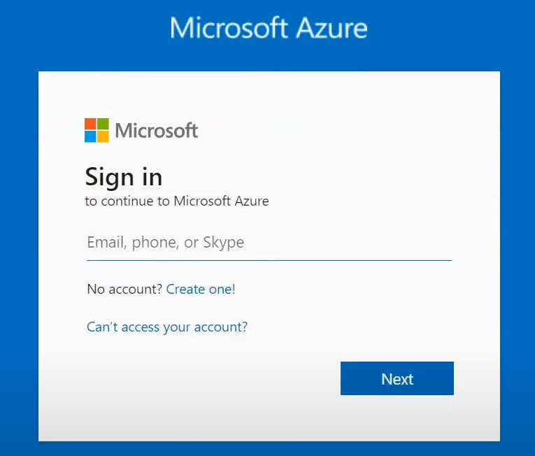

Login the new user

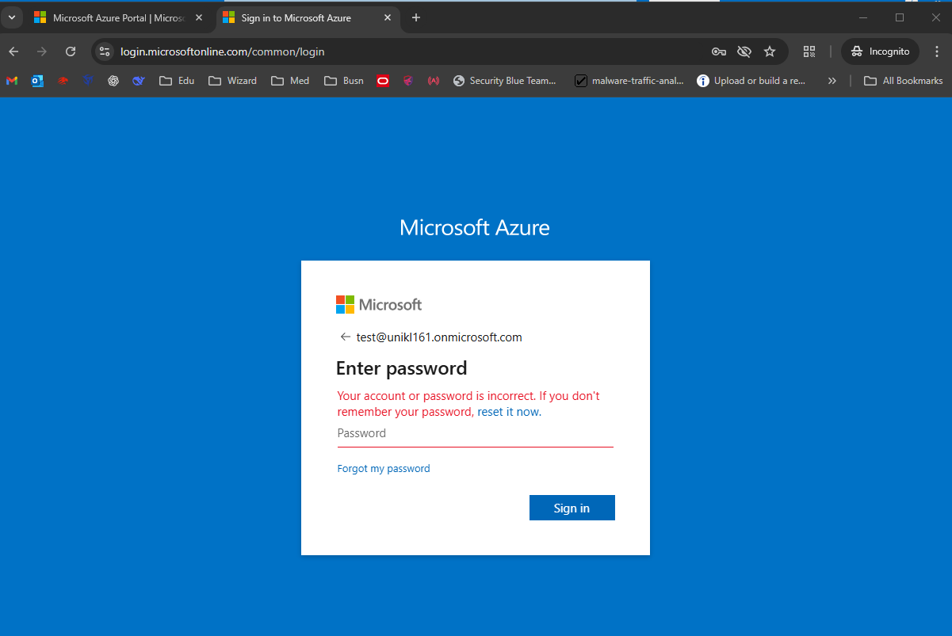

Failed the attempts to generate more logs

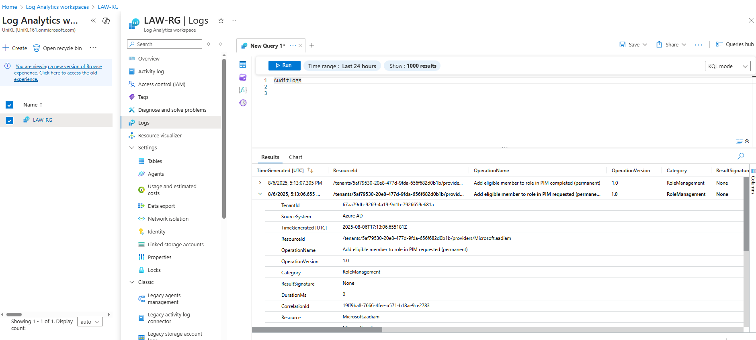

Result of auditLogs in Log Analytics Workspaces

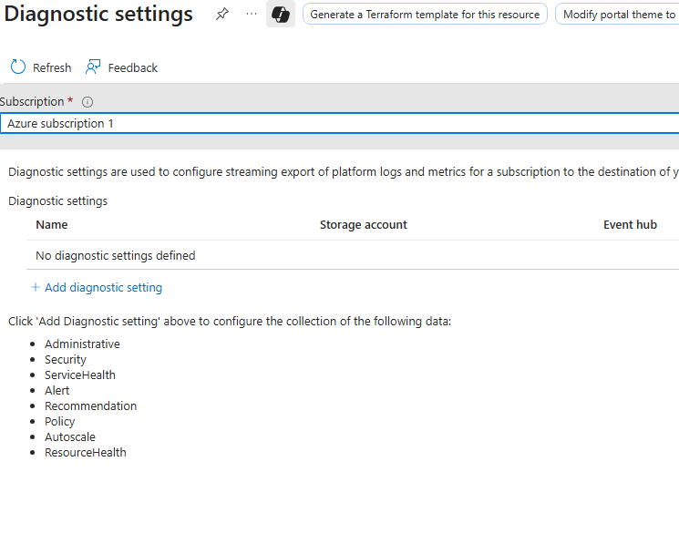

Add diagnostic settings

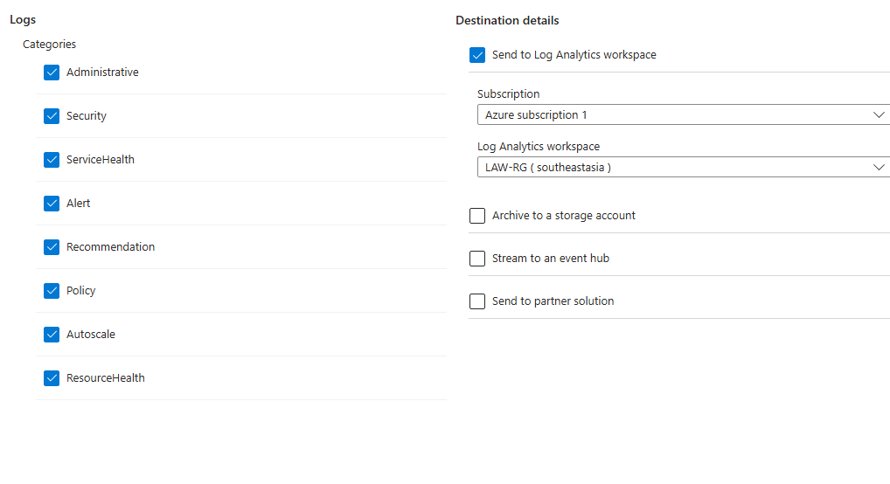

Select options as above

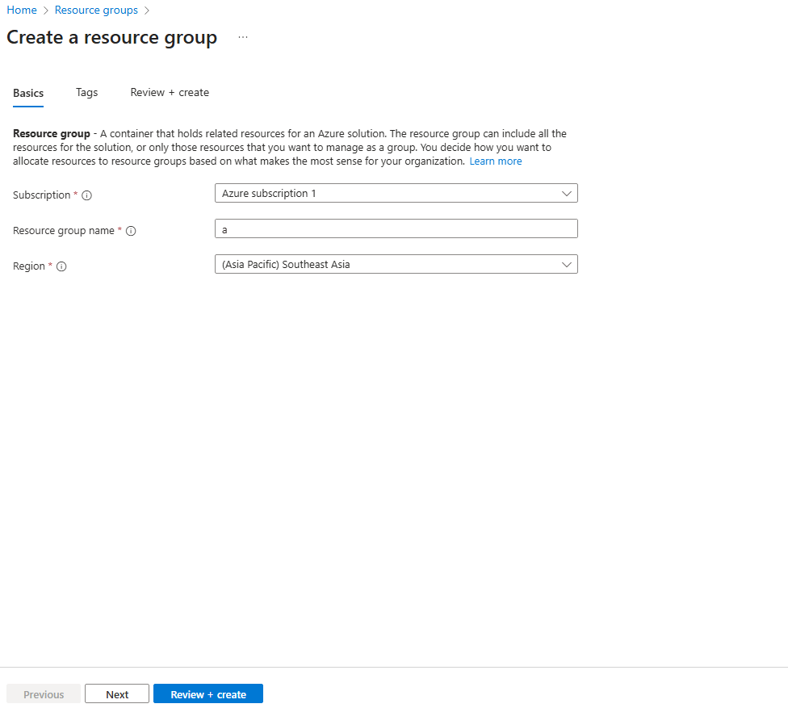

Create a resource group to test the log

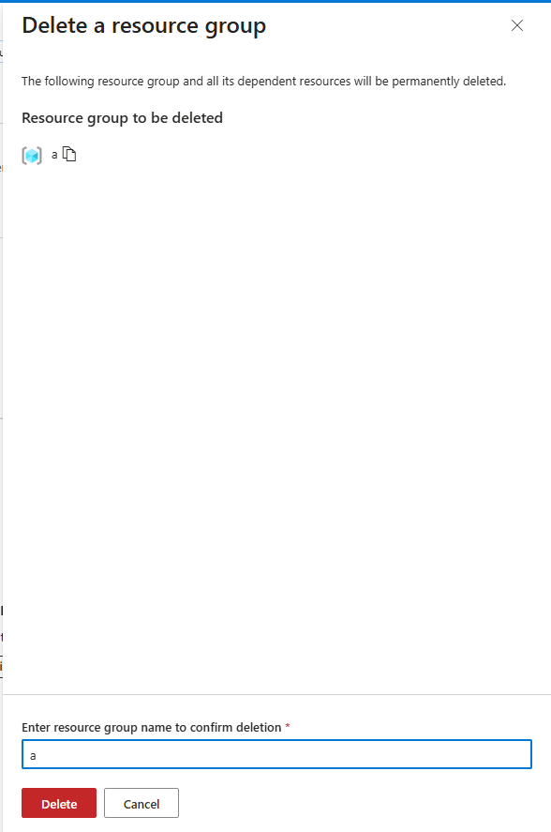

Delete the resource group

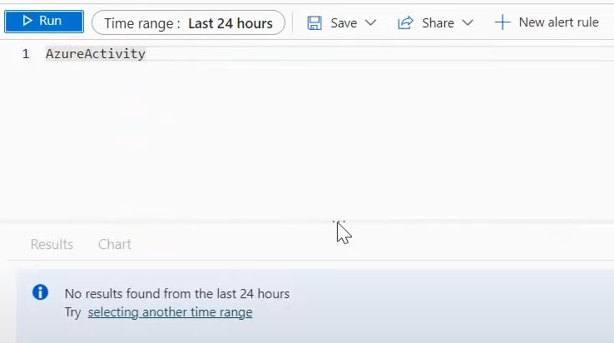

Query AzureActivity

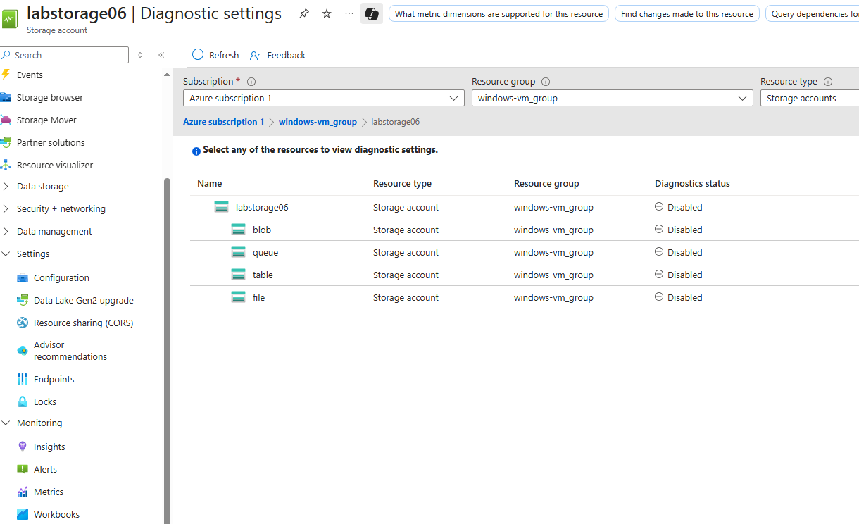

Go to Storage Accounts > Diagnostics settings > Select blob

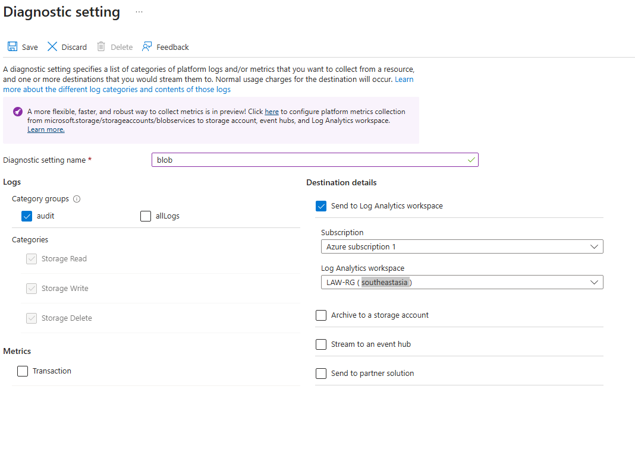

Add audit named blob and send to LAW

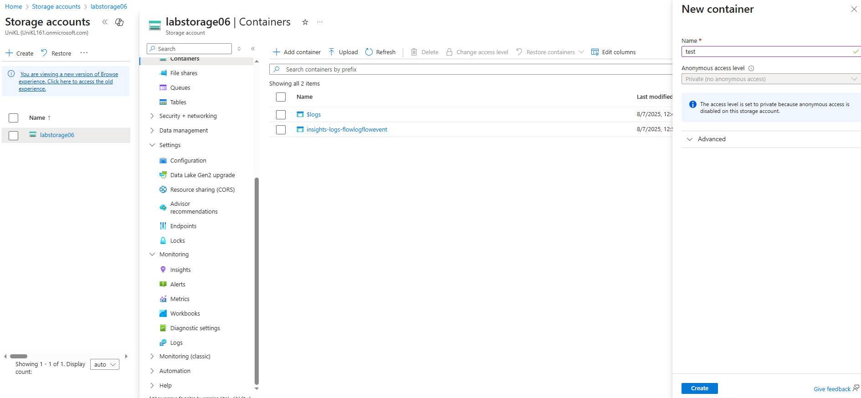

Go to lab storage in storage accounts and create **containers** named test to test the log

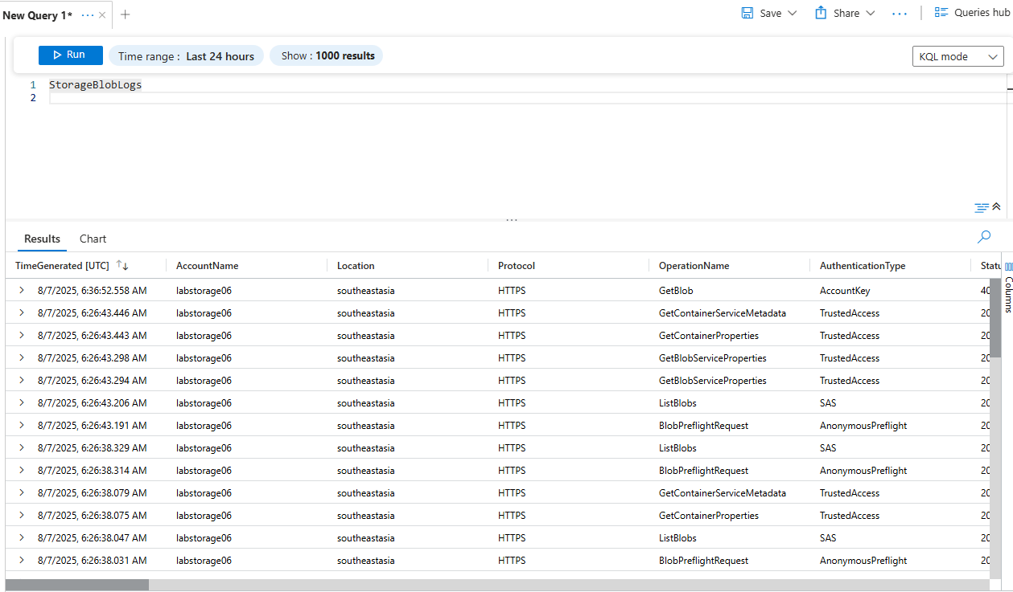

StorageBlobLogs KQL

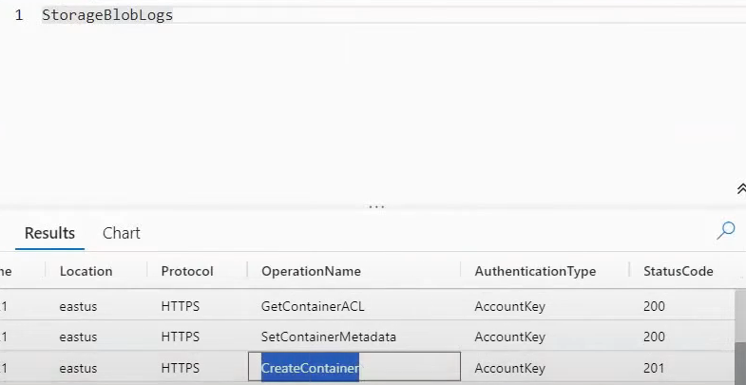

Create container log



SecurityEvent after a few hours of vm creation

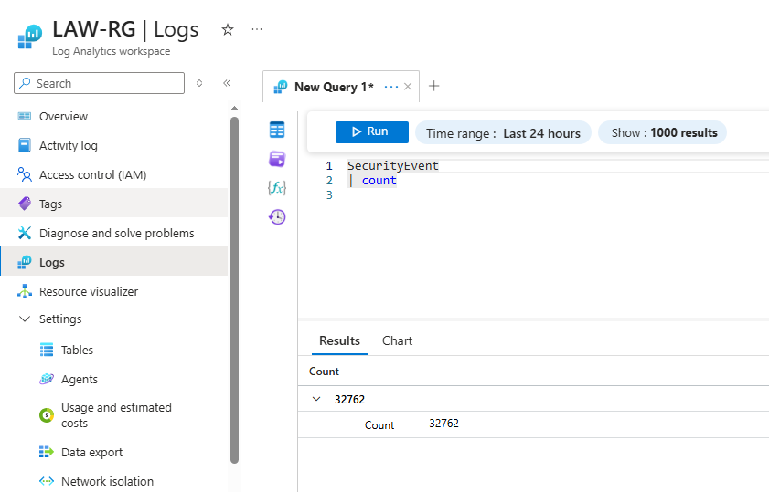

Security event count using KQL

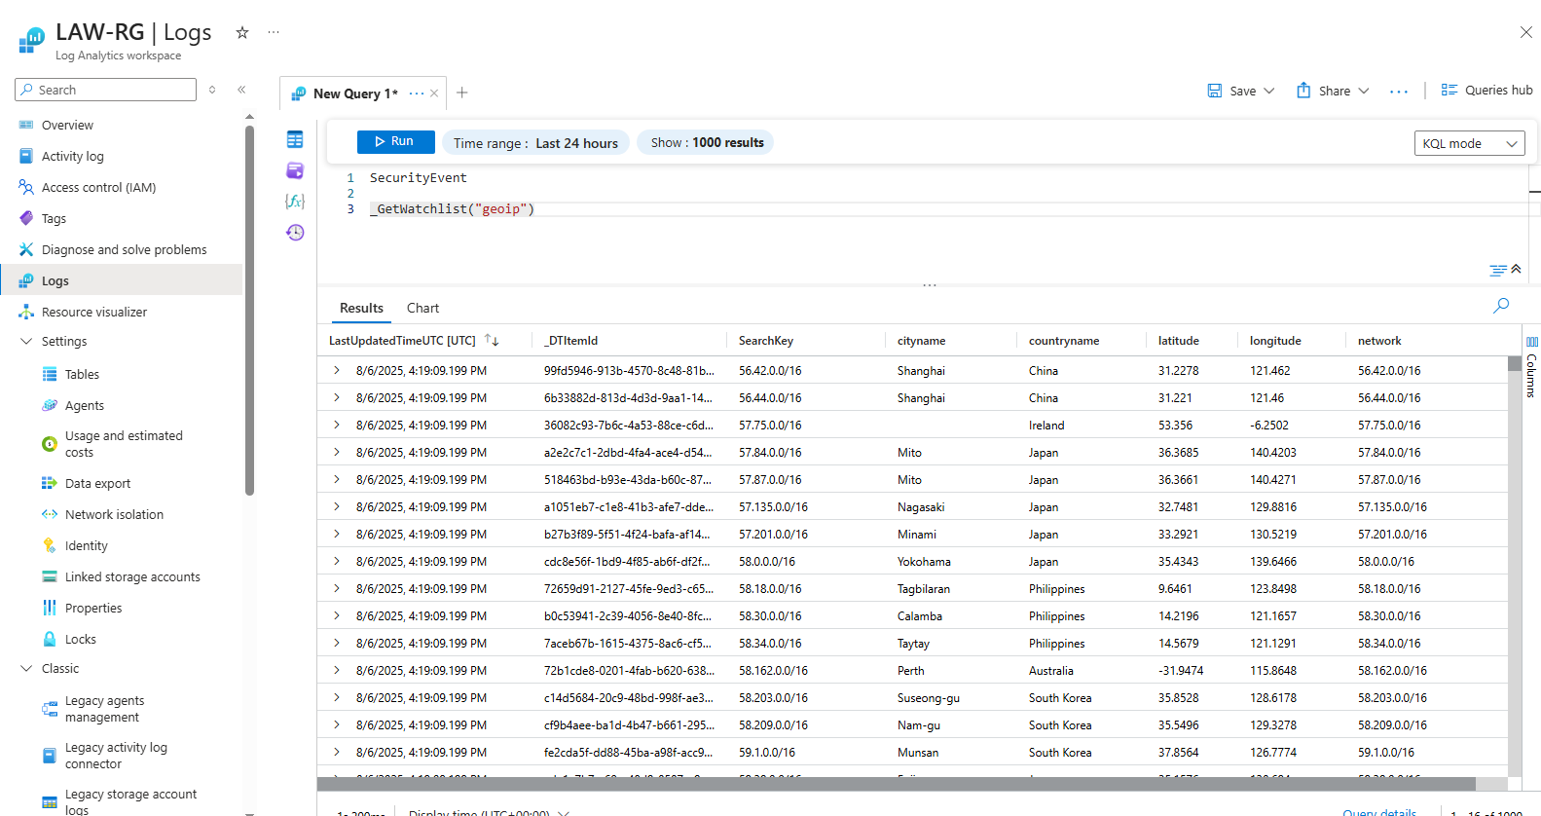

SecurityEvent with geoip

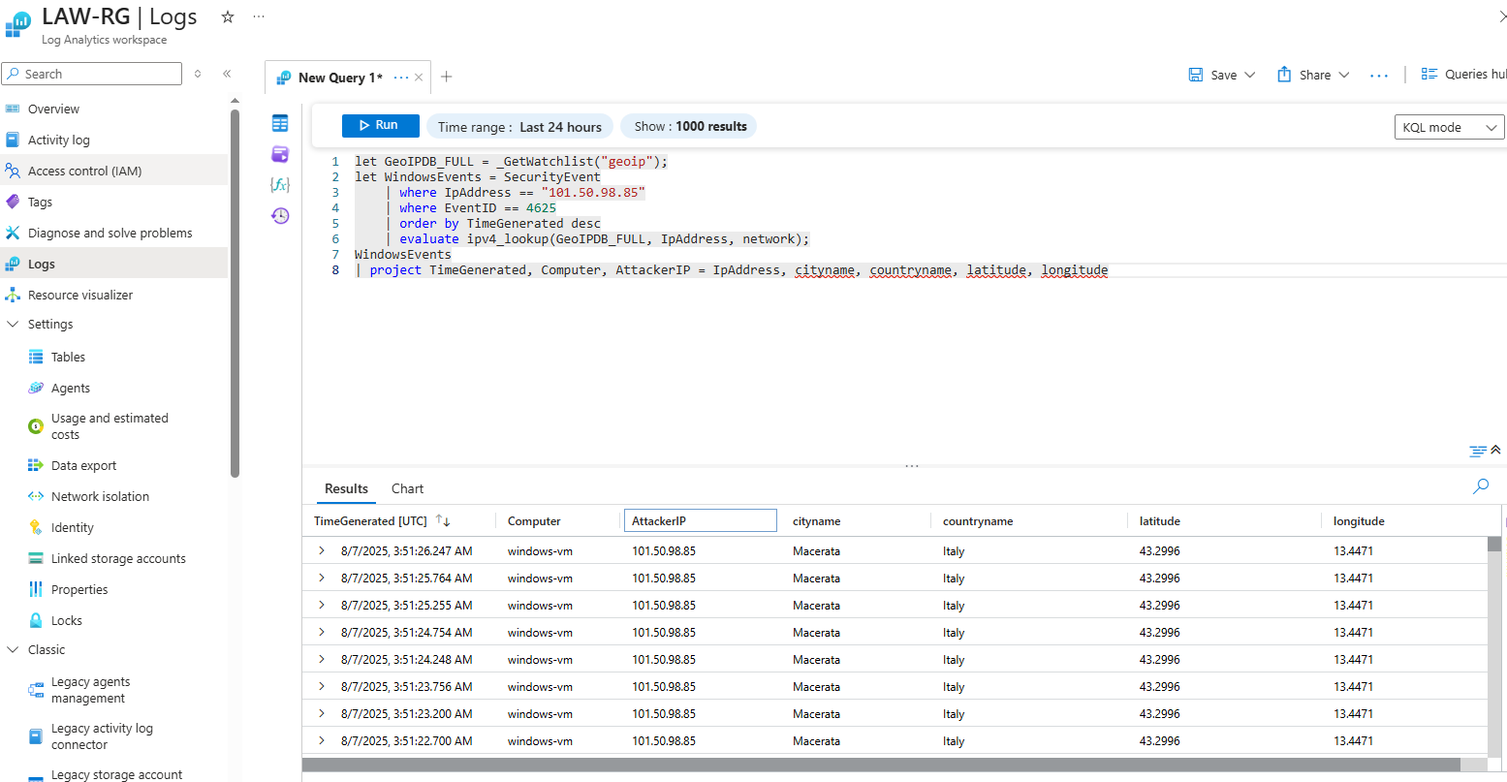

Investigate IP address with ‘geoip’ using KQL

## Part 5. Visualize Attack Map Creation & Detect

### Create Sentinel Workbooks

• Build workbooks for visualizing RDP/SSH/SQL attack maps (use GeoIP watchlist).

• Within Sentinel, create a new Workbook. Delete the prepopulated elements and add a “Query” element. Go to the advanced editor tab, and paste the JSON

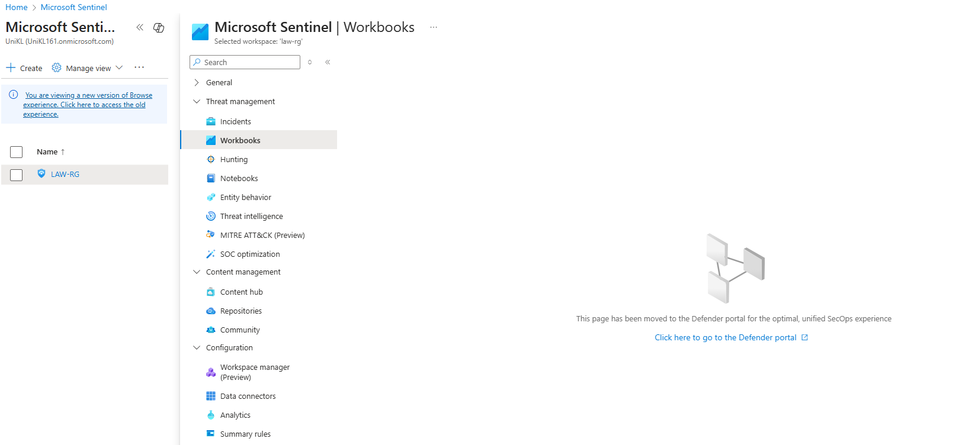

Microsoft Sentinel Workbook

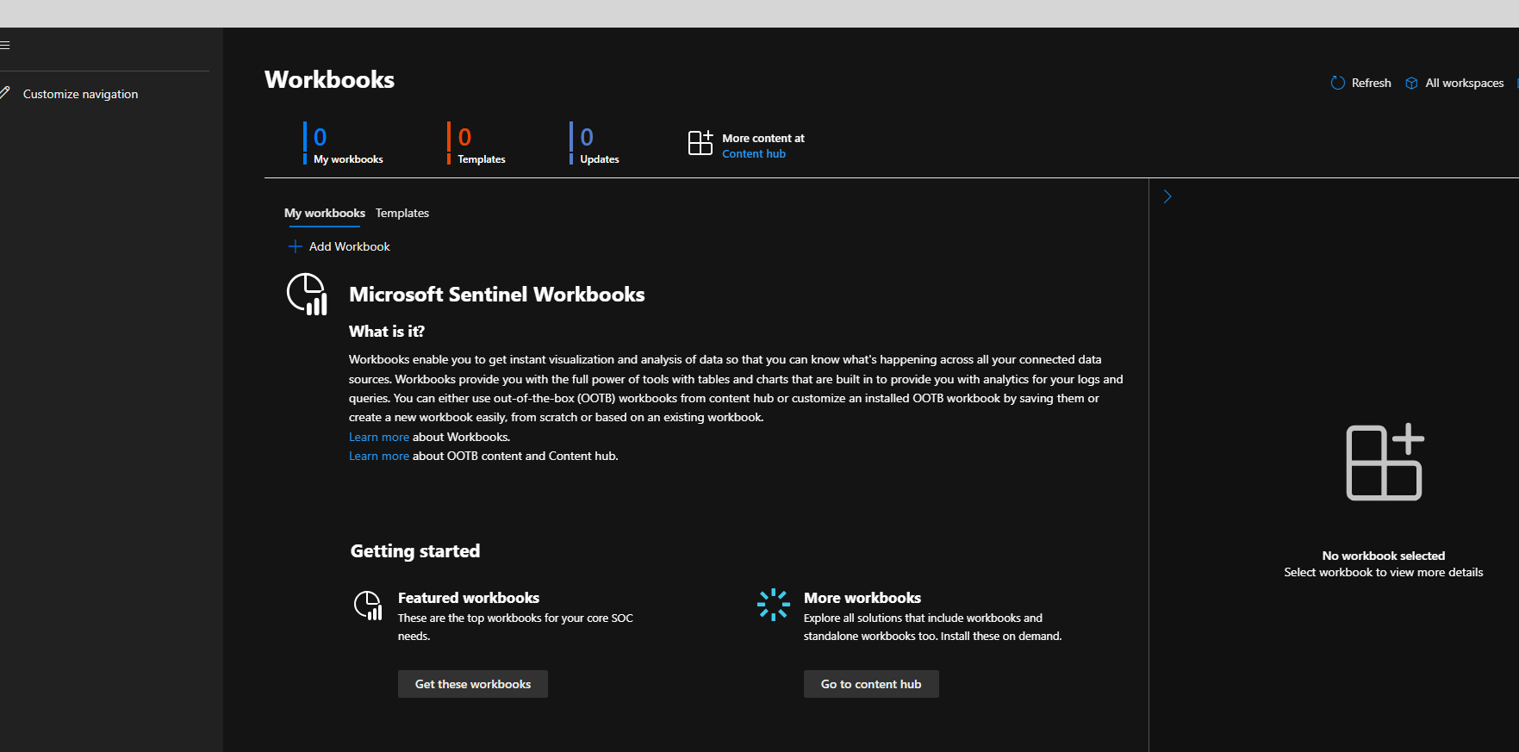

Click Add Workbook

* Default overview workbook will look like this but we want to create the heatmap so just delete it.

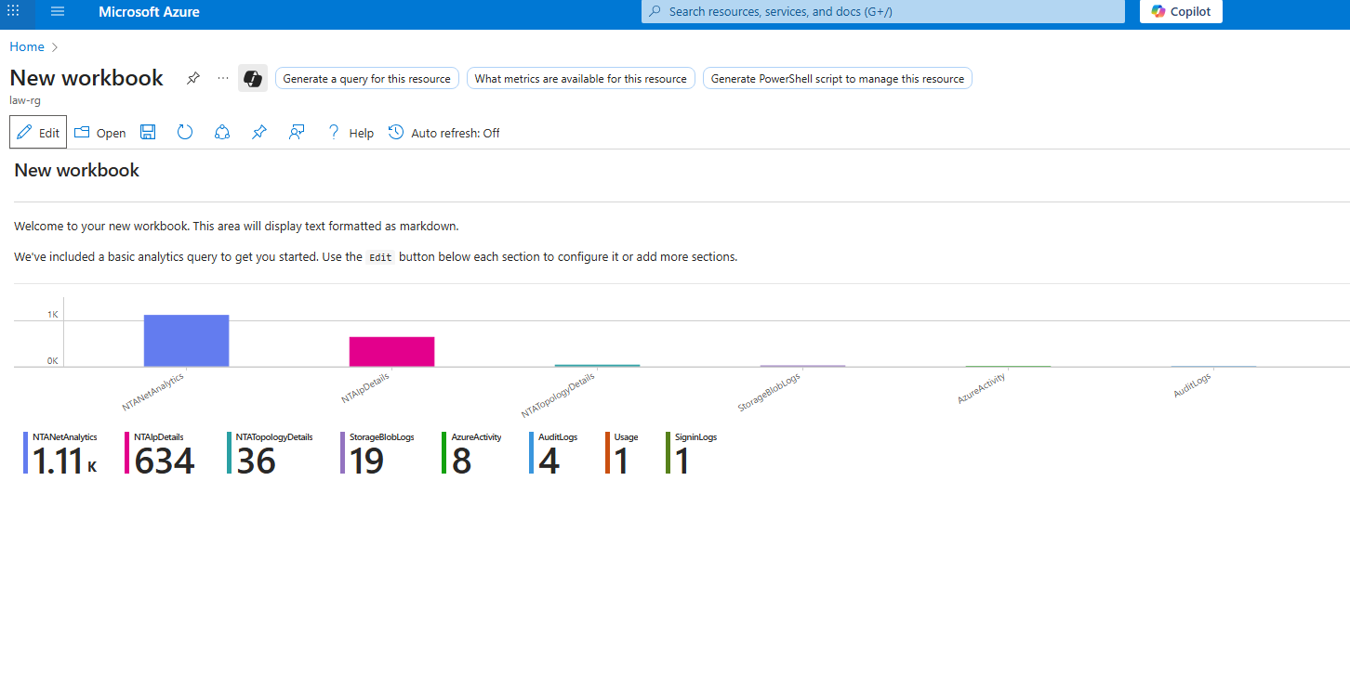

Default overview of workbook

* Create new workbook and click ‘add query’.

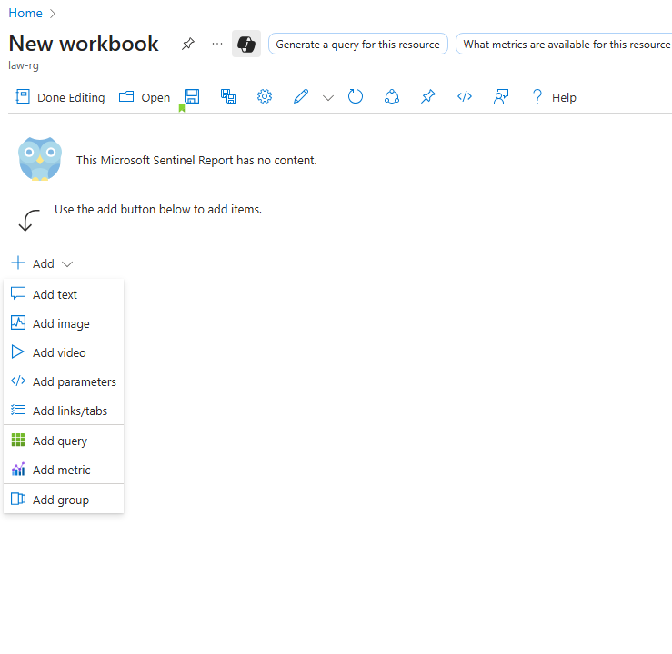

* Go to advanced editor to put Json code and click done editing after finished.

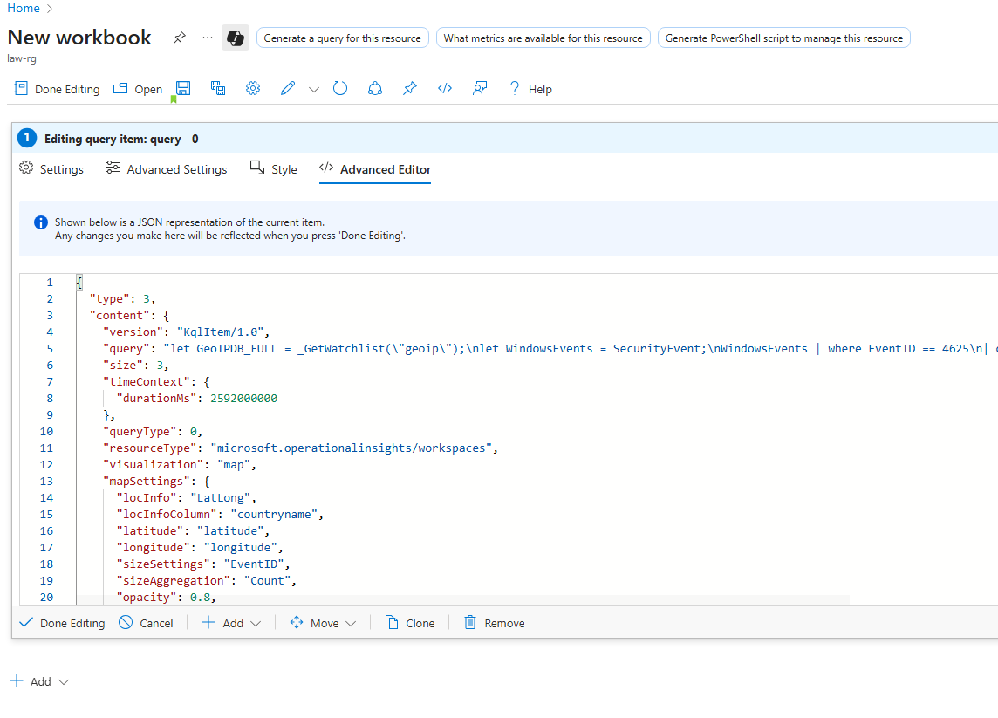

Paste Json

|  |
| --- |
| {  “type”: 3,  “content”: {  “version”: “KqlItem/1.0”,  “query”: “let GeoIPDB_FULL = _GetWatchlist(\”geoip\”);\nlet WindowsEvents = SecurityEvent;\nWindowsEvents | where EventID == 4625\n| order by TimeGenerated desc\n| evaluate ipv4_lookup(GeoIPDB_FULL, IpAddress, network)\n| summarize FailureCount = count() by IpAddress, latitude, longitude, cityname, countryname\n| project FailureCount, AttackerIp = IpAddress, latitude, longitude, city = cityname, country = countryname,\nfriendly_location = strcat(cityname, \” (\”, countryname, \”)\”);”,  “size”: 3,  “timeContext”: {  “durationMs”: 2592000000  },  “queryType”: 0,  “resourceType”: “icrosoft.operationalinsights/workspaces”,  “visualization”: “map”,  “mapSettings”: {  “locInfo”: “LatLong”,  “locInfoColumn”: “countryname”,  “latitude”: “latitude”,  “longitude”: “longitude”,  “sizeSettings”: “FailureCount”,  “sizeAggregation”: “Sum”,  “opacity”: 0.8,  “labelSettings”: “friendly_location”,  “legendMetric”: “FailureCount”,  “legendAggregation”: “Sum”,  “itemColorSettings”: {  “nodeColorField”: “FailureCount”,  “colorAggregation”: “Sum”,  “type”: “heatmap”,  “heatmapPalette”: “greenRed”  }  }  },  “name”: “query – 0”  } |

Full Json code windows authentication failed

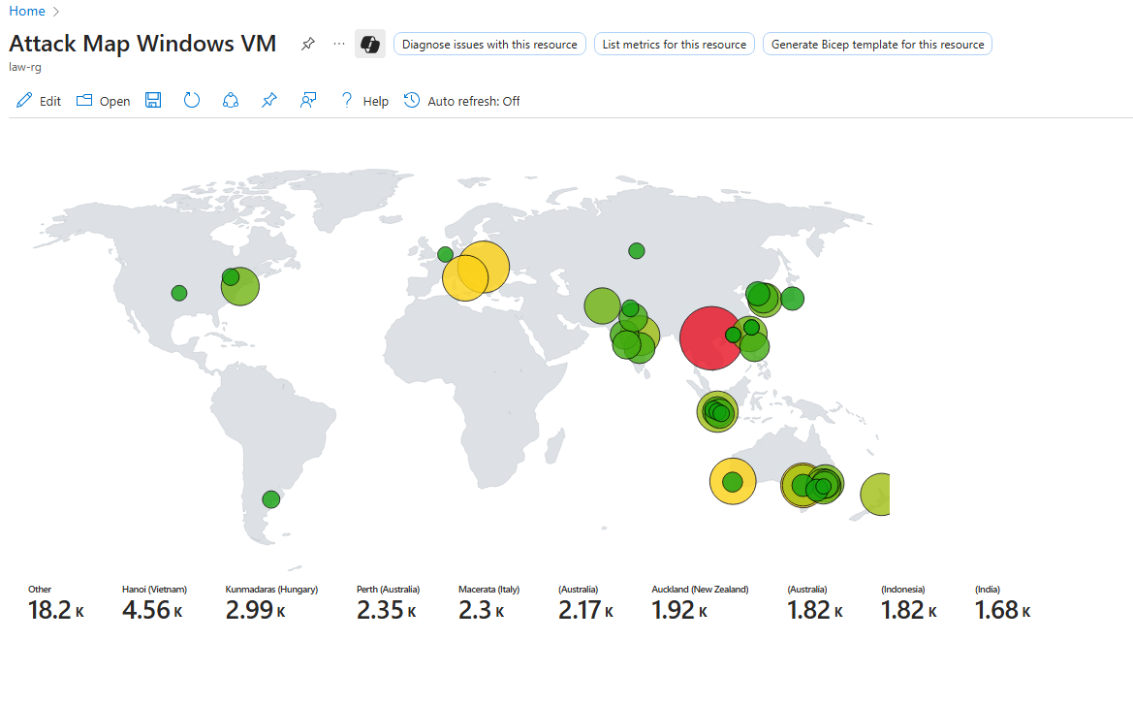

Attack Map for Windows RDP Authentication Failed

|  |
| --- |
| {  "type": 3,  "content": {  "version": "KqlItem/1.0",  "query": "let GeoIPDB_FULL = _GetWatchlist(\"geoip\");\nlet IpAddress_REGEX_PATTERN = @\"\\b\\d{1,3}\\.\\d{1,3}\\.\\d{1,3}\\.\\d{1,3}\\b\";\nSyslog\n| where Facility == \"auth\"\n| where SyslogMessage startswith \"Failed password for\"\n| order by TimeGenerated desc\n| project TimeGenerated, SourceIP = extract(IpAddress_REGEX_PATTERN, 0, SyslogMessage), DestinationHostName = HostName, DestinationIP = HostIP, Facility, SyslogMessage, ProcessName, SeverityLevel, Type\n| evaluate ipv4_lookup(GeoIPDB_FULL, SourceIP, network)\n| project TimeGenerated, SourceIP, DestinationHostName, DestinationIP, Facility, SyslogMessage, ProcessName, SeverityLevel, Type, latitude, longitude, city = cityname, country = countryname, friendly_location = strcat(cityname, \" (\", countryname, \")\");",  "size": 3,  "timeContext": {  "durationMs": 2592000000  },  "queryType": 0,  "resourceType": "microsoft.operationalinsights/workspaces",  "visualization": "map",  "mapSettings": {  "locInfo": "LatLong",  "locInfoColumn": "countryname",  "latitude": "latitude",  "longitude": "longitude",  "sizeSettings": "latitude",  "sizeAggregation": "Count",  "opacity": 0.8,  "labelSettings": "friendly_location",  "legendMetric": "friendly_location",  "legendAggregation": "Count",  "itemColorSettings": {  "nodeColorField": "latitude",  "colorAggregation": "Count",  "type": "heatmap",  "heatmapPalette": "greenRed"  }  }  },  "name": "query - 0"  } |

Full Json code linux authentication failed

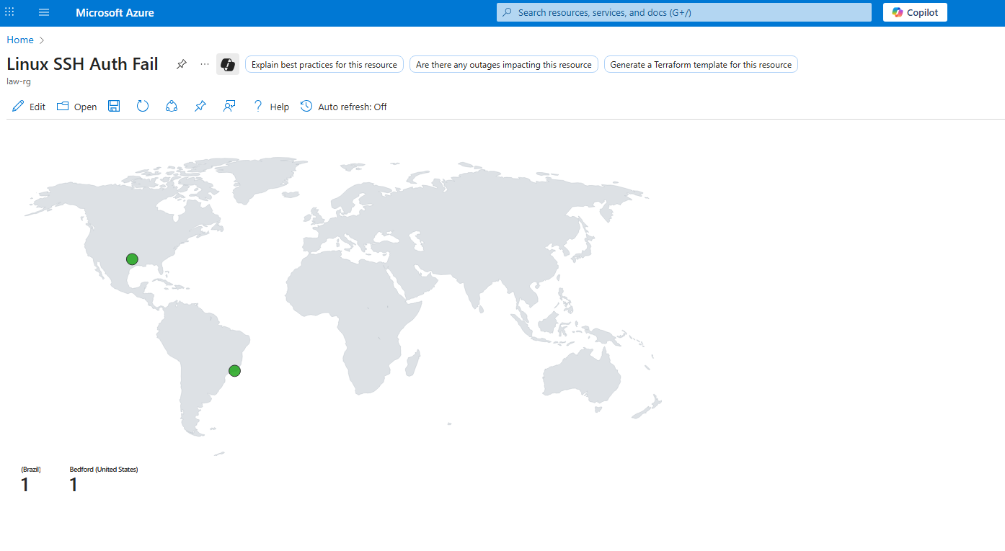

Attack Map for Linux SSH Authentication Failed

### Import Analytics Rules

• Import detection rules (e.g., brute force detection) and tune thresholds. Trigger detections via attacker VM actions.

• Create incidents by importing *Sentinel-Analytics-Rules(KQL Alert Queries).json* file

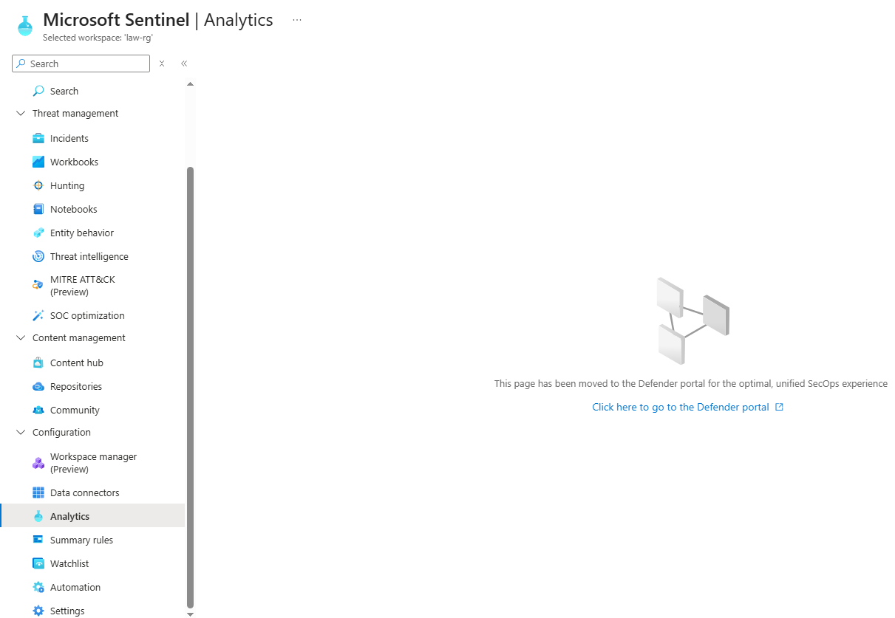

Click Analytics in Microsoft Sentinel

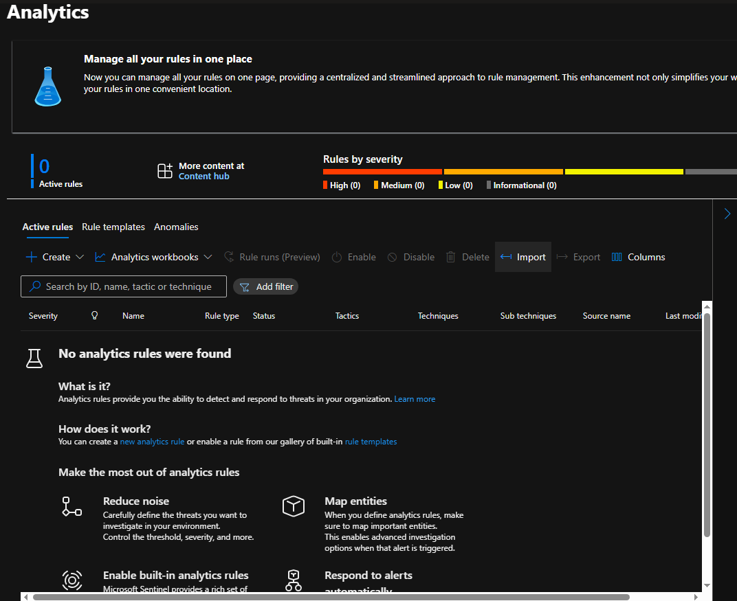

In defender portal click import *Sentinel-Analytics-Rules(KQL Alert Queries).json* file

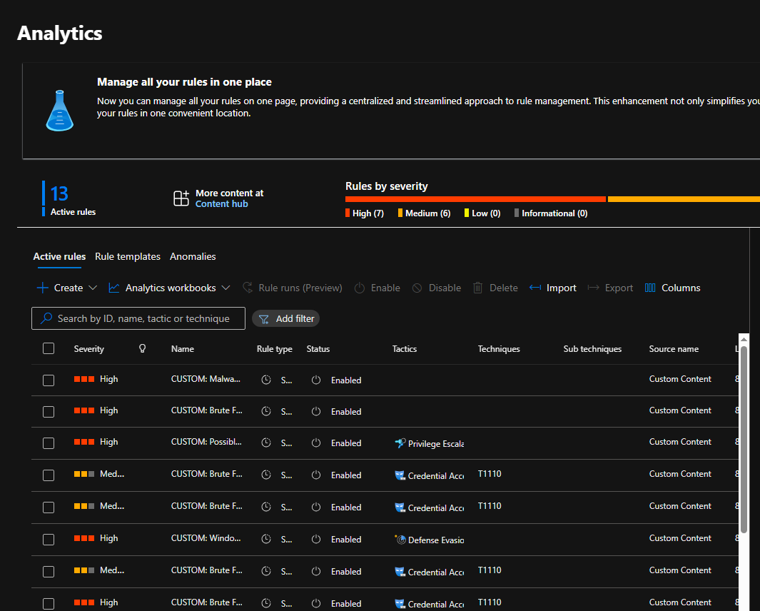

Incident Report

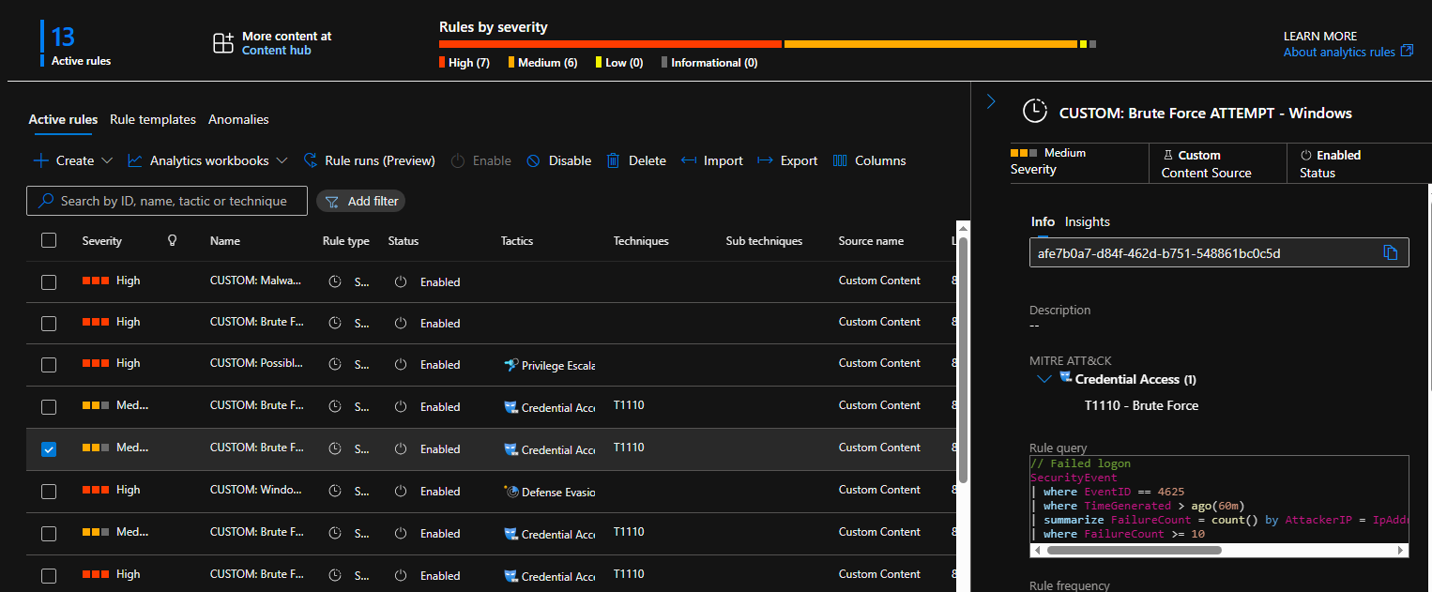

Example of brute force attempt on windows

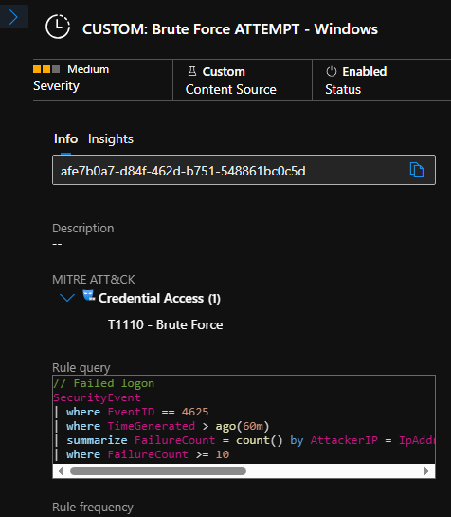

Query that return to trigger brute force attempt

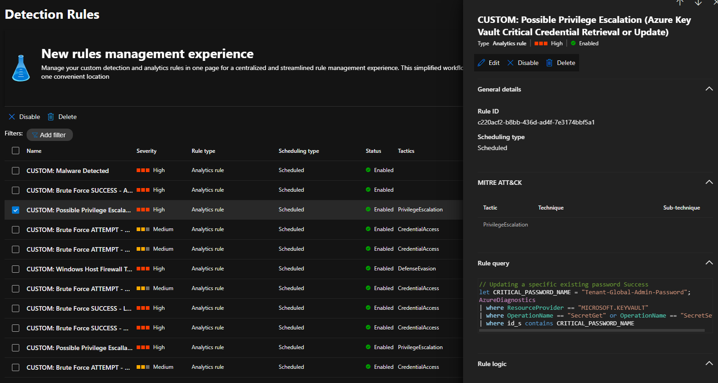

Possible privilege escalation from azure key vault

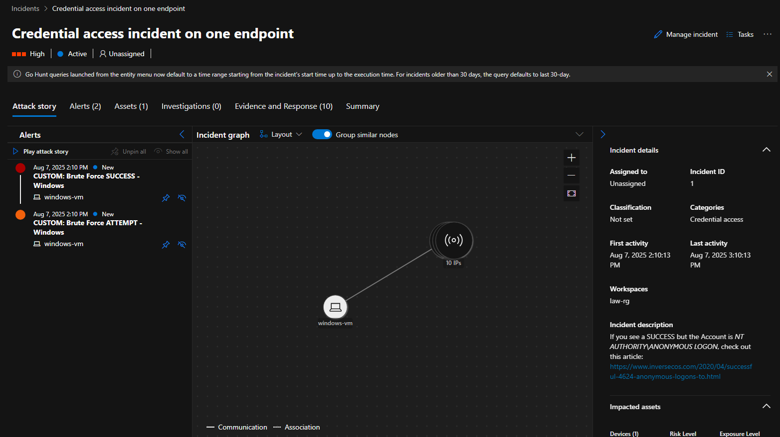

Credential access incident graph on one endpoint

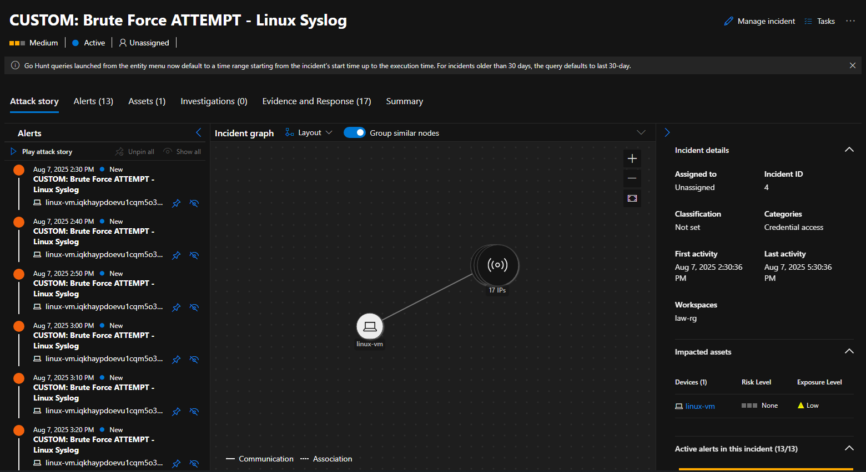

Brute force attempt – linux syslog

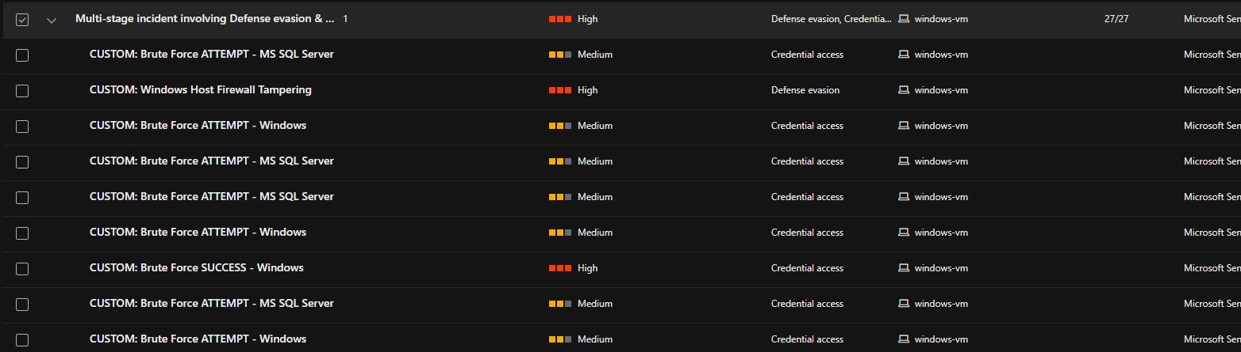

Shows variety brute force attempt attacks include MS SQL Server, Firewall tampering, windows credential access

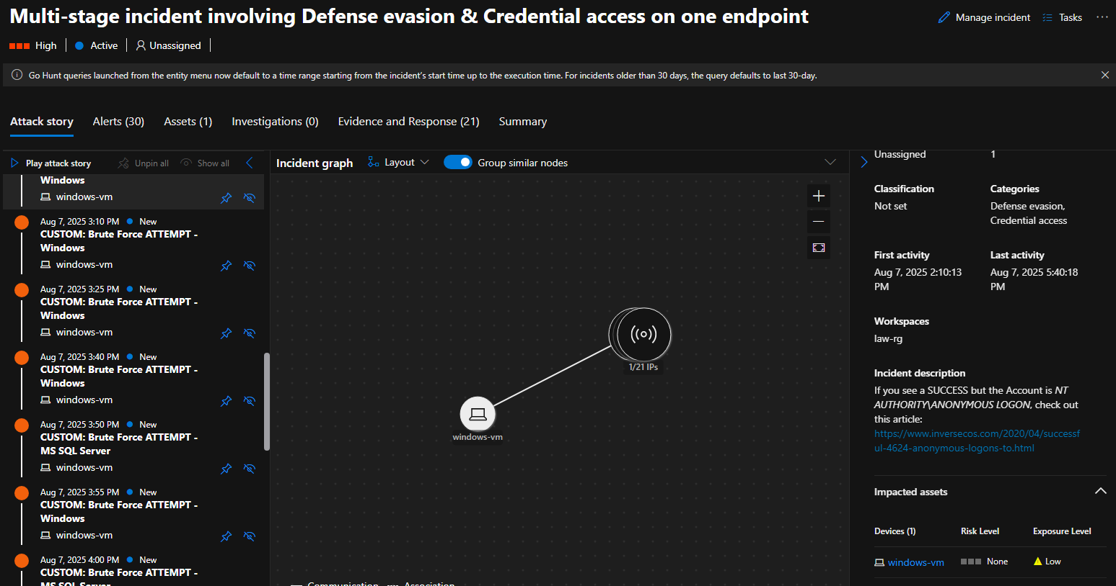

Multi-stage incident involving defense evasion and credential access

## Phase 6 — Remediate and Incident Response

**Investigate and** **Remediate**

• Secure NSG rule with both **windows** and **linux vm**

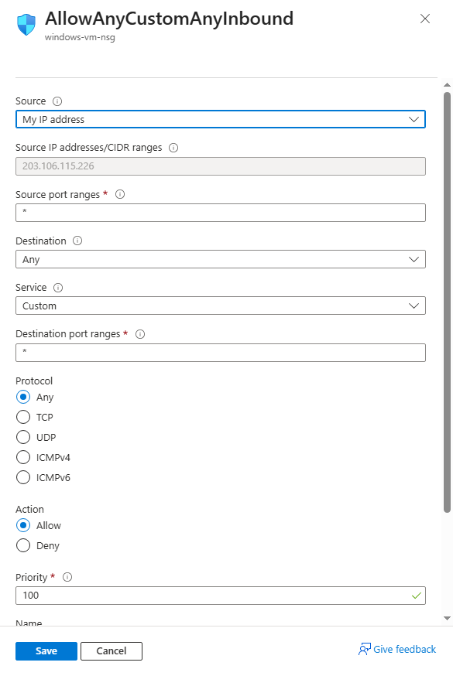

Configure back NSG rule with only my IP address as source

### Respond to Incidents

• In Sentinel, open incidents, review evidence, assign owner, add notes, and close incidents once remediated.

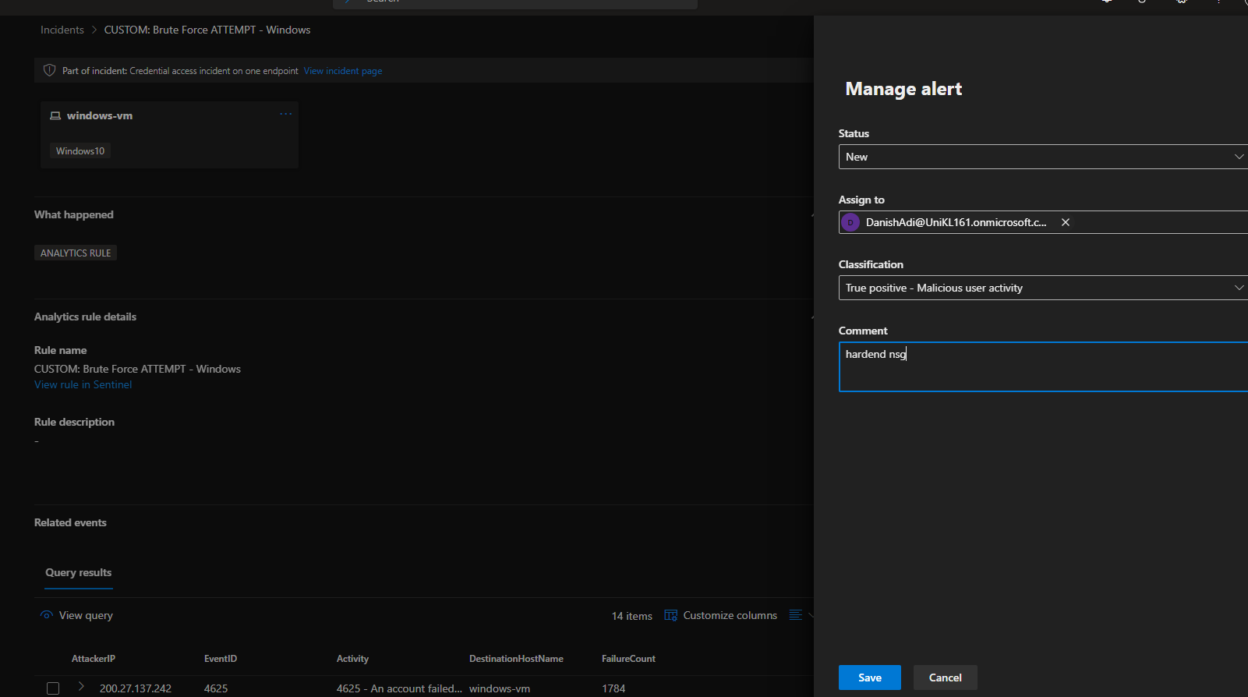

### Harden Infrastructure

• Re-enable Windows Firewall, remove or decommission Attacker-VM.

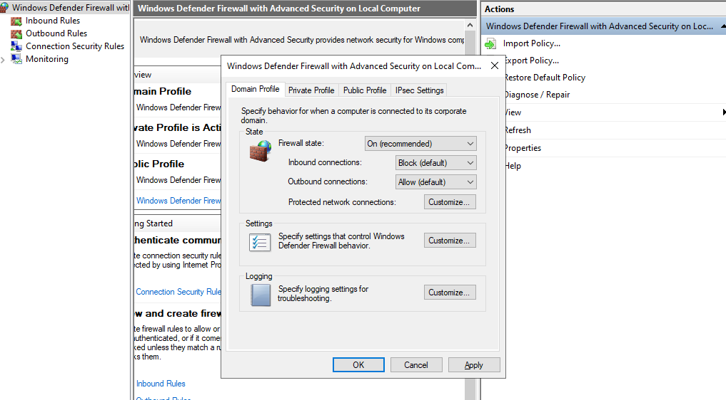

Domain profile firewall

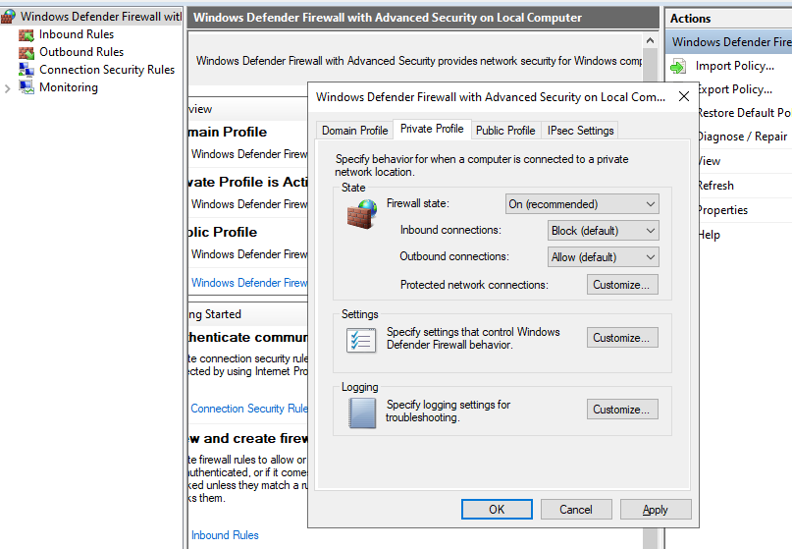

Private profile firewall

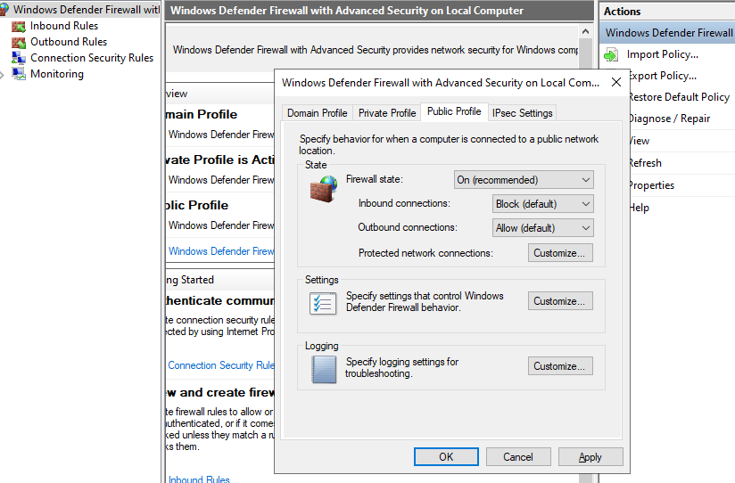

Public profile firewall